CRM Application for Jewel Management - (Developer)

**College Name:** KPR COLLEGE OF ARTS SCIENCE AND RESEARCH

**College Code :** bruaz

**TEAM ID:** NM2025TMID21463

**TEAM LEADER:** SRI HARI V

**EMAIL**: 23bai050@kprcas.ac.in

**TEAM MEMBER 1**: THARANI T

**EMAIL**: 23bai055@kprcas.ac.in

**TEAM MEMBER 2**: PRITESH R S

**EMAIL**: 23bai038@kprcas.ac.in

**TEAM MEMBER 3**: VIGNESWARI M

**EMAIL**: 23bai058@kprcas.ac.in

**TEAM MEMBER 4**: VARSHA A

**EMAIL**: 23bai056@kprcas.ac.in

Title : CRM Application for Jewel Management - (Developer)

**Project Overview :**

The Jewel Inventory System is a comprehensive software Solution designed to streamline and manage the inventory and sales processes of a jewellery store or a jewellery manufacturer. The system aims to provide an efficient and user-friendly solution to track and control the inventory of various jewellery items, maintain accurate records, and facilitate seamless sales transactions.

**Objectives :**

* **Efficient Inventory Management** – Accurately track jewellery items by type, weight, purity, and pricing.
* **Real-Time Stock Monitoring** – Update inventory levels instantly to prevent stock-outs or overstocking.
* **Sales and Billing Automation** – Automate invoicing, discounts, and payment tracking for faster transactions.
* **Secure Record Keeping** – Maintain a protected database of all inventory and sales activities.
* **User-Friendly Interface** – Ensure easy navigation for users with varying technical skills.
* **Reporting and Analytics** – Provide actionable insights through sales and inventory reports.
* **Role-Based Access Control** – Restrict system access based on user roles to enhance security.

**Student Outcomes:**

* Practical Inventory Management Skills – Students learn to build systems that track jewellery stock by key attributes like weight and purity.
* Understanding of Retail Business Processes – Students gain insight into how inventory and sales workflows operate in a jewellery business.
* Application Development Lifecycle Experience – Students experience the full project cycle from planning to deployment.
* Database Design and Record-Keeping Proficiency – Students develop skills in designing secure and structured data storage solutions.
* User Interface and Experience Design – Students learn to create intuitive interfaces suited for real-world end users.
* Teamwork and Project Collaboration – Students enhance collaboration skills by working in development teams.
* Exposure to Industry Tools and Concepts – Students become familiar with features like reporting, role-based access, and optional barcode integration.

**System Requirements :**

**Hardware Requirements:**

* Computer with min/sum 4 GB RAM, Dual-core processor
* Stable internet connection

**Software Requirements:**

* Salesforce Developer Edition Org
* Modern Web Browser (e.g., Google Chrome, Firefox)

# Creating Developer Account

Creating a developer org in salesforce.

1. Go to <https://developer.salesforce.com/signup>
2. On the sign up form, enter the following details :
3. First name & Last name
4. Email
5. Role : Developer
6. Company : College Name
7. County : India
8. Postal Code : pin code
9. Username : should be a combination of your name and company This need not be an actual email id, you can give anything in the format

: [username@organization.com](mailto:username@organization.com)

Click on sign me up after filling these.

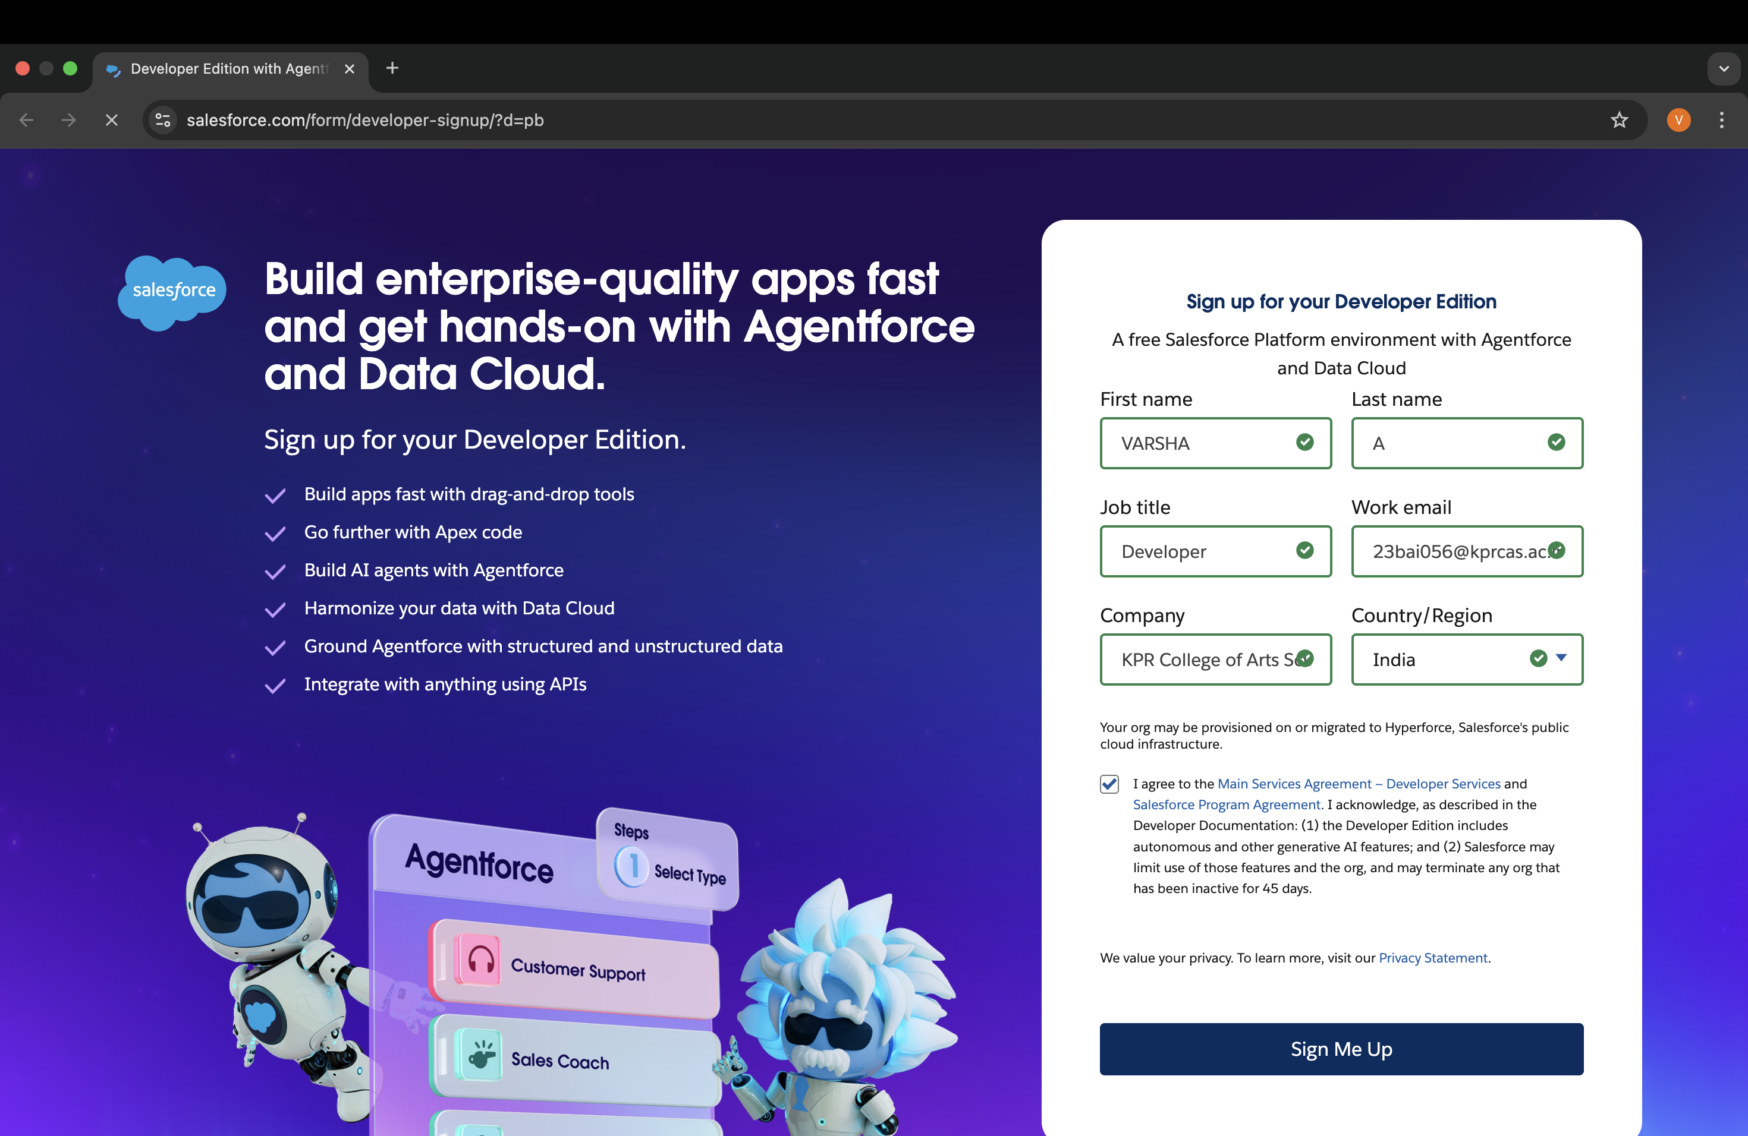

# Account Activation

1. Go to the inbox of the email that you used while signing up. Click on the Reset Password to activate your account. The email may take 5-10mins.
2. Click on Reset Password
3. Give a password and answer a security question and click on change password.
4. Then you will redirect to your salesforce setup page.

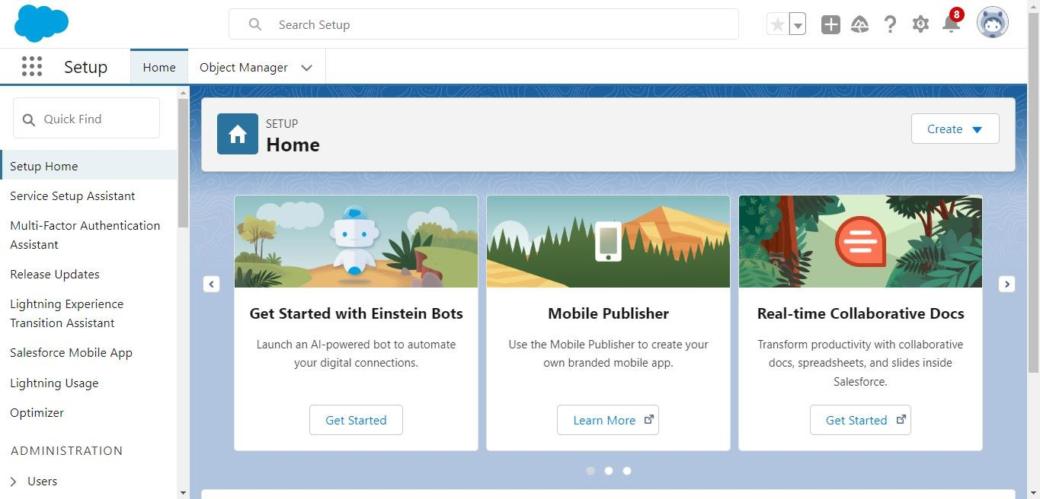

# Create Jewel Customer Object

The purpose of creating a Jewel Customer custom object is to store and manage information about Customer.

To create an object:

1. From the setup page >> Click on Object Manager >> Click on Create >> Click on Custom Object.
2. Enter the label name : Jewel Customer
3. Plural label name : Jewel Customers
4. Enter Record Name Label and Format
   * Record Name >> Customer name
   * Data Type >> Text
5. Click on Allow reports.
6. Allow search and click Save.

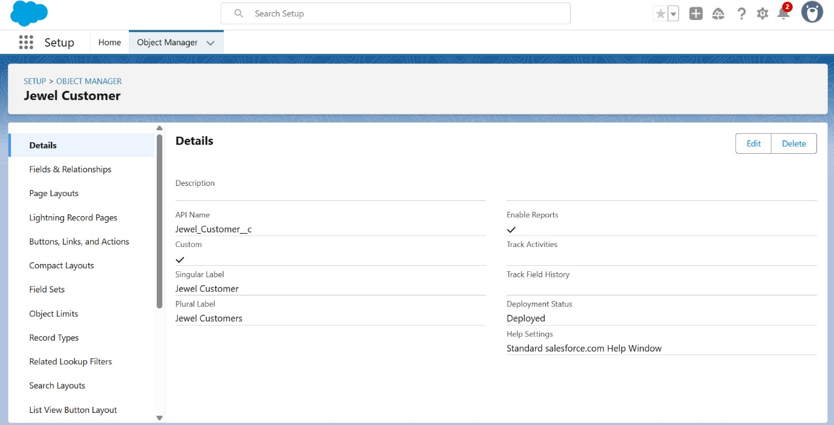

# Create Item Object

The purpose of creating a Item object is to manage the inventory of gold and silver items.

To create an object:

1. From the setup page >> Click on Object Manager >> Click on Create >> Click on Custom Object.
   1. Enter the label name >> Item
   2. Plural label name >> Items
   3. Enter Record Name Label and Format
      * Record Name >> Item Id
      * Data Type >> Auto Number
      * Display Format >> Item-{00}
      * Starting Number >> 1
2. Click on Allow reports.
3. Allow search >> Save.

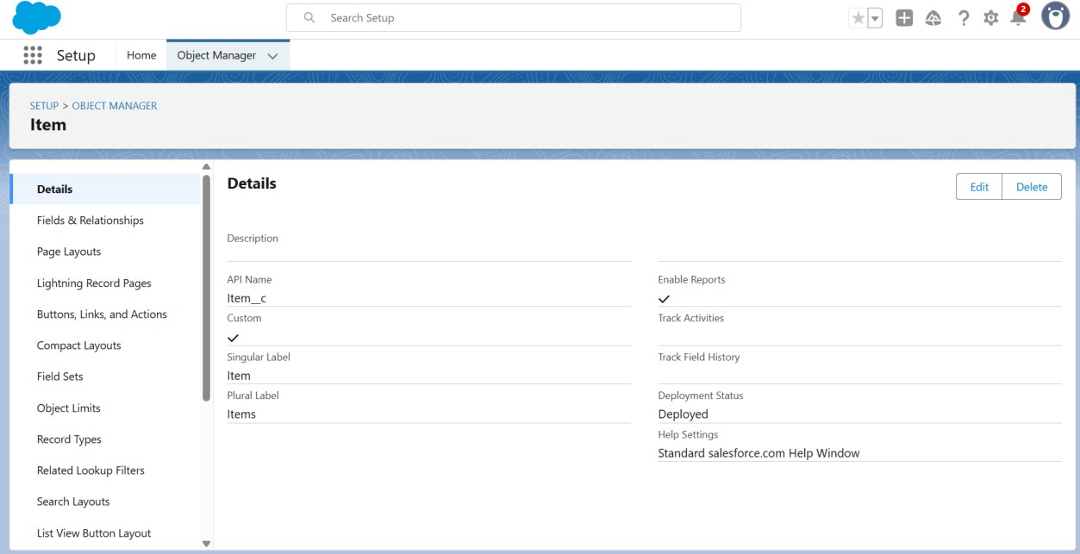

# Create Customer Order Object

The purpose of creating a Item object is to manage the inventory of gold and silver items.

To create an object:

1. From the setup page >> Click on Object Manager >> Click on Create >> Click on Custom Object.
   1. Enter the label name >> Customer Order
   2. Plural label name >> Customer Orders
   3. Enter Record Name Label and Format
      * Record Name >> Customer Order Id
      * Data Type >> Auto Number
      * Display Format >> Item-{00}
      * Starting Number >> 1
2. Click on Allow reports.
3. Allow search >> Save.

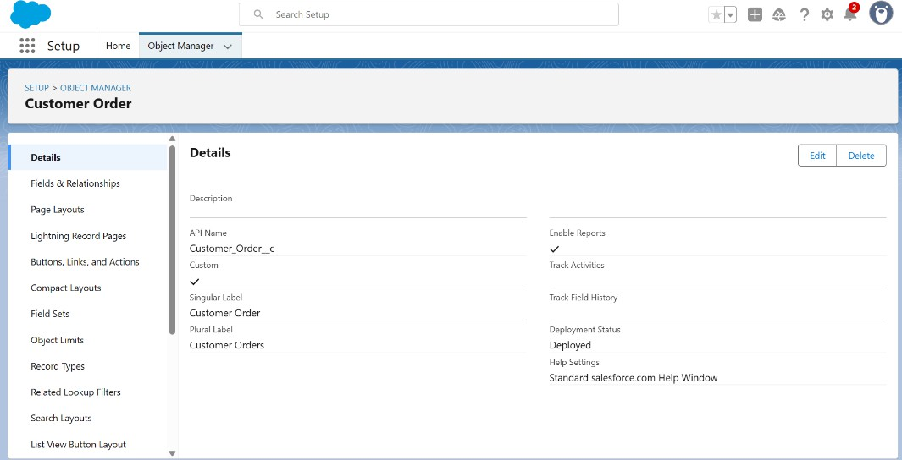**Create Price Object**

The purpose of creating a Item object is to manage the inventory of gold and silver items.

To create an object:

1. From the setup page >> Click on Object Manager >> Click on Create >> Click on Custom Object.
2. Enter the label name >> Price
3. Plural label name >> Prices
4. Enter Record Name Label and Format
   * Record Name >> Price Id
   * Data Type >> Auto Number
   * Display Format >> Item-{00}
   * Starting Number >> 1
5. Click on Allow reports.
6. Allow search >> Save.

**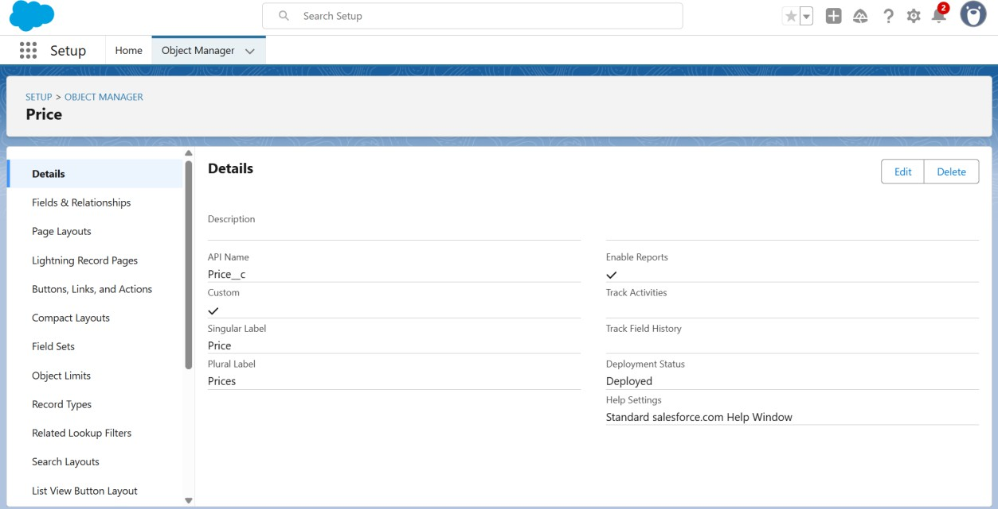****Create Billing Object**

The purpose of creating a Item object is to manage the inventory of gold and silver items.

To create an object:

1. From the setup page >> Click on Object Manager >> Click on Create >> Click on Custom Object.
2. Enter the label name >> Billing
3. Plural label name >> Billings
4. Enter Record Name Label and Format
   * Record Name >> Billing Id
   * Data Type >> Auto Number
   * Display Format >> Item-{00}
   * Starting Number >> 1
5. Click on Allow reports.
6. Allow search >> Save.

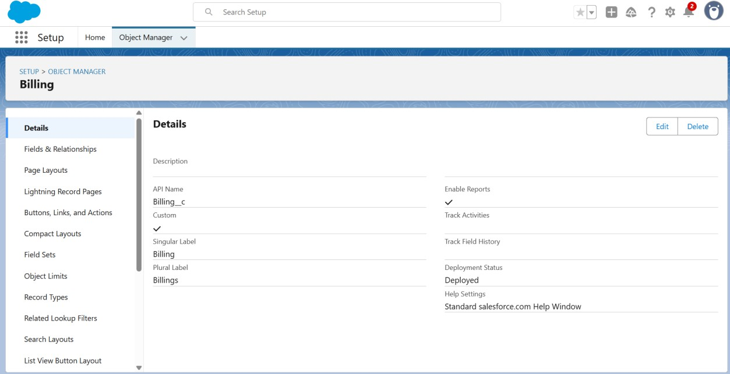

# Creating a Custom Tab

To create a Tab:(Customer)

1. Go to setup page >> type Tabs in Quick Find bar >> click on tabs >> New (under custom object tab)
2. Select Object(Jewel Customer) >> Select any tab style >> Next (Add to profiles page) keep it as default >> Next (Add to Custom App) keep it as default >> Save.

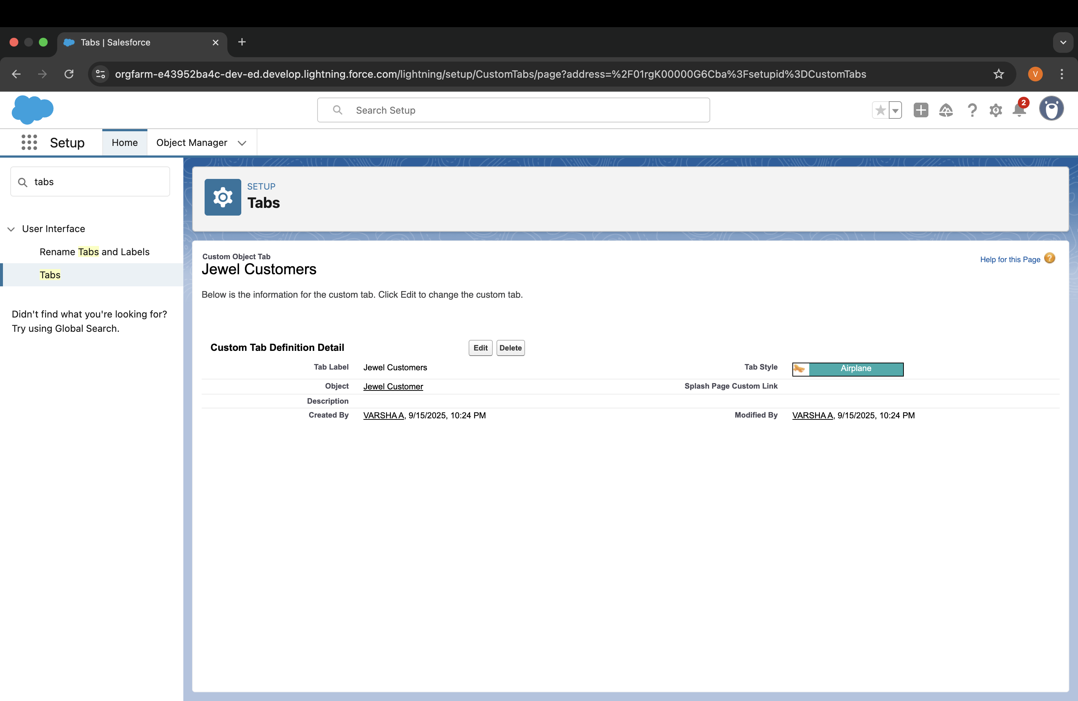

# To create a Tab:(Item)

1. Go to setup page >> type Tabs in Quick Find bar >> click on tabs >> New (under custom object tab)
2. Select Object(Item) >> Select the tab style >> Next (Add to profiles page) keep it as default >> Next (Add to Custom App) keep it as default >> Save.

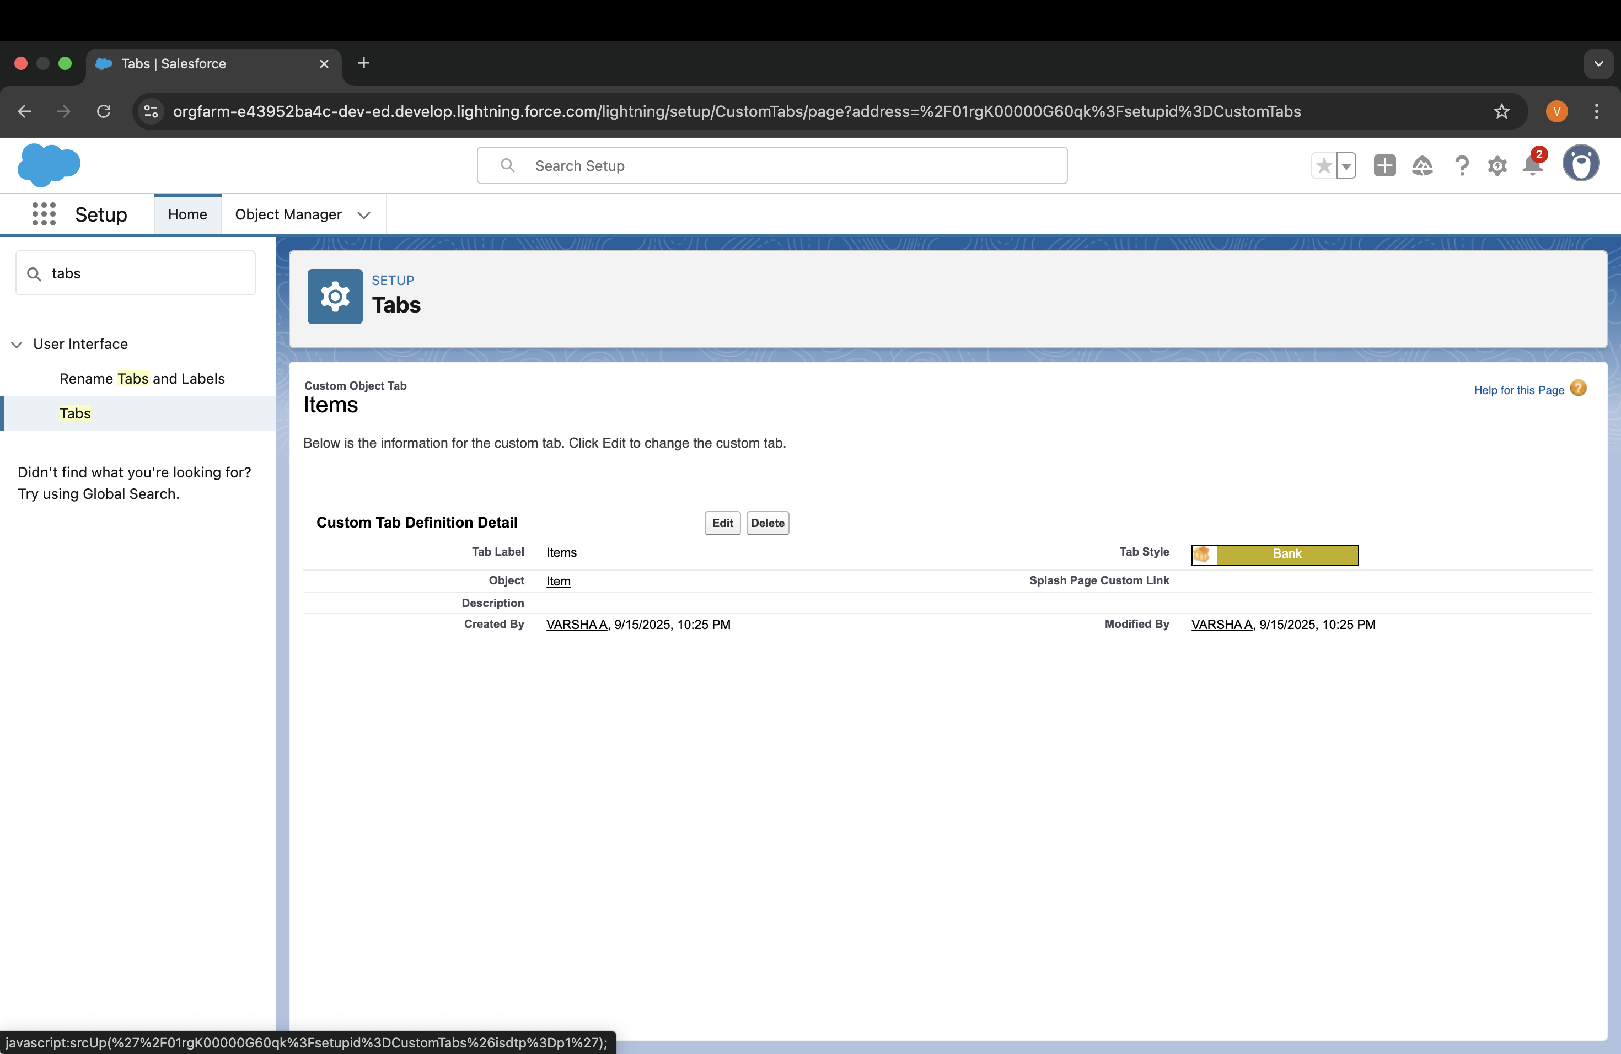

# To create a Tab:( Customer Order)

* 1. Go to setup page >> type Tabs in Quick Find bar >> click on tabs >> New (under custom object tab)
  2. Select Object(Customer Order) >> Select the tab style >> Next (Add to profiles page) keep it as default >> Next (Add to Custom App) keep it as default >> Save.

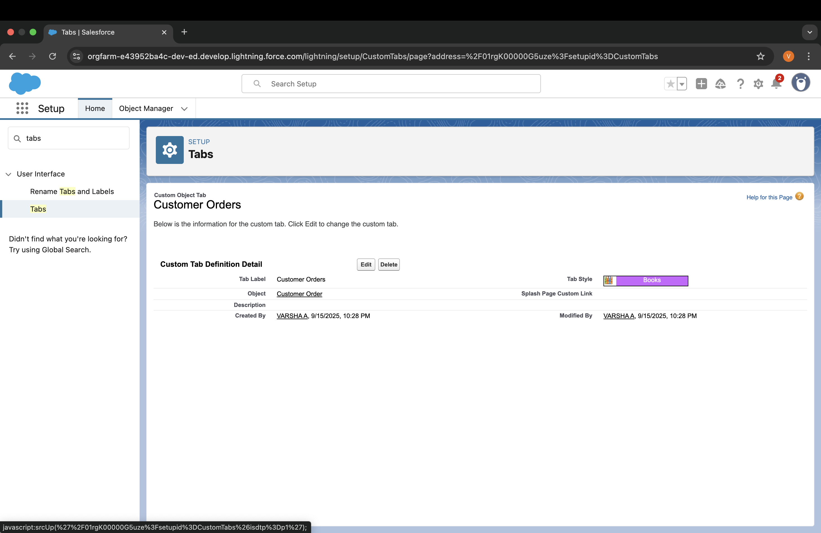

# To create a Tab:( Price)

1. Go to setup page >> type Tabs in Quick Find bar >> click on tabs >> New (under custom object tab)
2. Select Object(Price) >> Select the tab style >> Next (Add to profiles page) keep it as default >> Next (Add to Custom App) keep it as default >> Save.

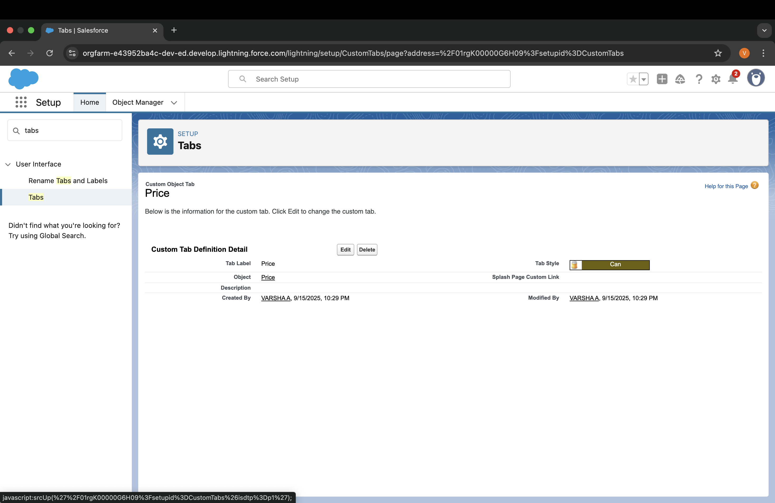

# To create a Tab:( Billing)

1. Go to setup page >> type Tabs in Quick Find bar >> click on tabs >> New (under custom object tab)
2. Select Object(Billing) >> Select the tab style >> Next (Add to profiles page) keep it as default >> Next (Add to Custom App) keep it as default

>> Save.

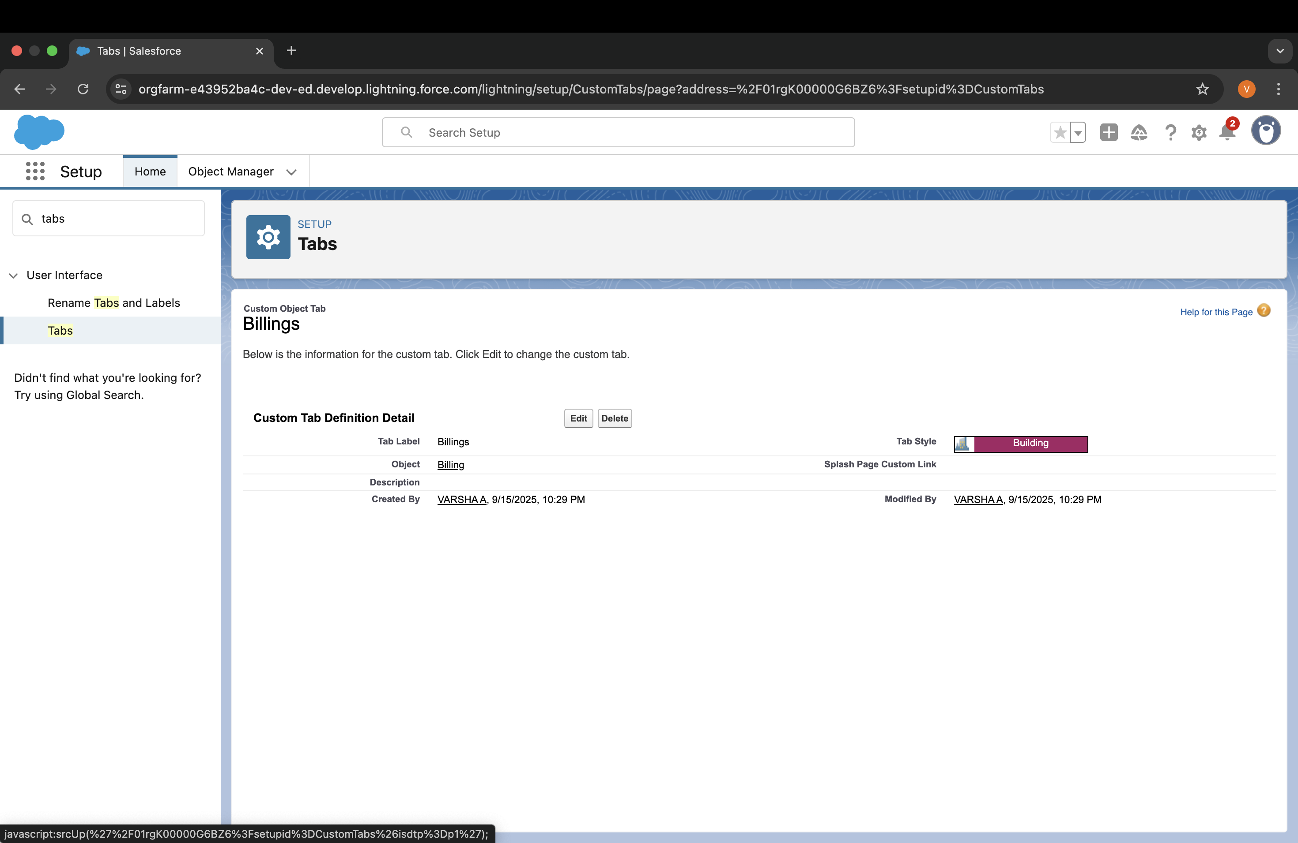

# Create a Lightning App

To create a lightning app page:

1. Go to setup page >> search “app manager” in quick find >> select “app manager” >>
2. click on New lightning App.
3. Fill the app name in app details and branding as follow App Name : Jewellery Inventory System.

Developer Name : This will auto populated Description : Elevate your look with elegance

Image : optional (if you want to give any image you can otherwise not mandatory)

Primary colour hex value : keep this default.

1. Then click Next >> (App option page)Set Navigation Style as Console Navigation >> Next.
2. (Utility Items) keep it as default >> Next.
3. To Add Navigation Items
4. Search for the item in the (JewelCustomer,Item,CustomerOrder,Price,Billing,Reports, Dashboard) from the search bar and move it using the arrow button ? Next? Next.
5. To Add User Profiles:
6. Search profiles (System administrator) in the search bar >> click on the arrow button >> save & finish.

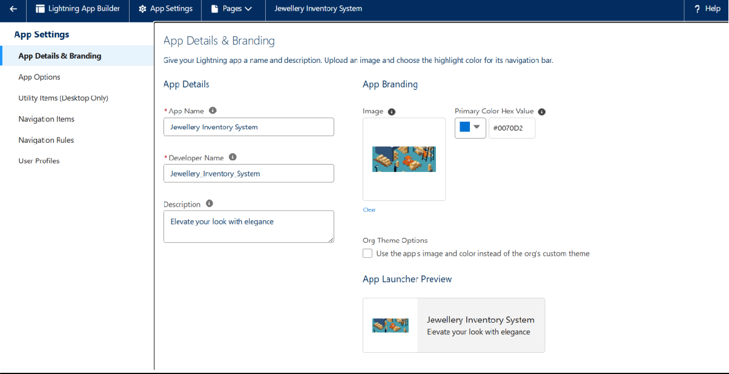

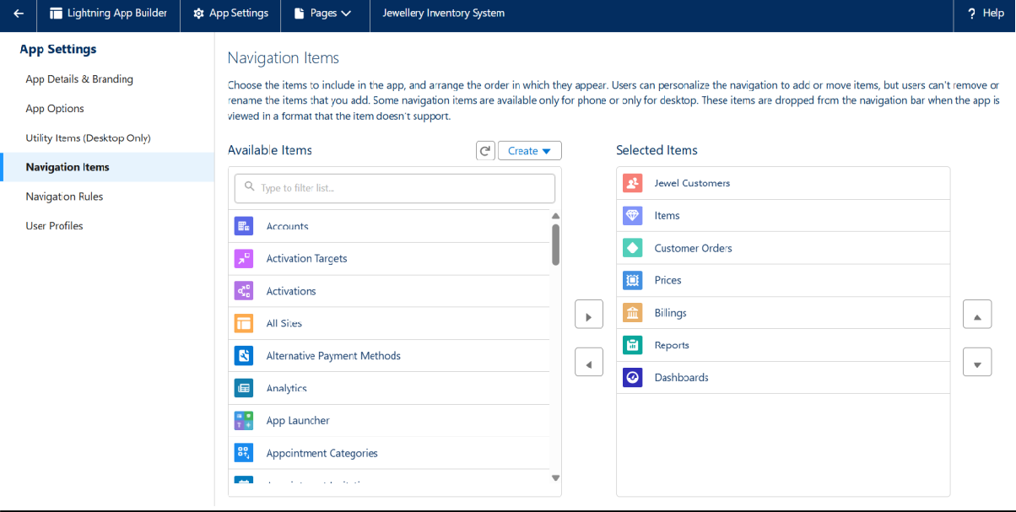

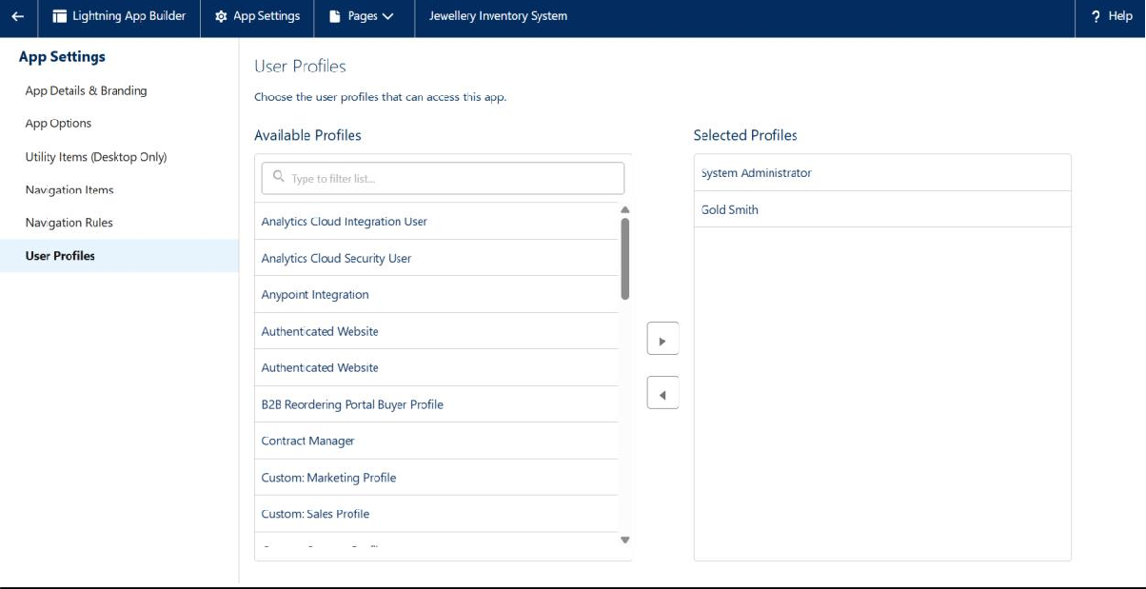

# Creating Lookup Relationship

## To Create a relationship between Jewel Customer & Customer Order Objects.

1. Go to the setup page >> click on object manager >> type object name(Customer Order) in the quick find bar >> click on the object.
2. Click on fields & relationship >> click on New.
3. Select “Lookup relationship” as data type and click Next.
4. Select the related object “ Jewel Customer ”.
5. Give Field Label as “Customer” and click Next.
6. Next >> Next >> Save.

# Creating a Master-Detail Relationship

**To Create a Master-Detail relationship :**

1. Go to the setup page >> click on object manager >> type object name(Customer Order) in the quick find bar >> click on the object.
2. Click on fields & relationships >> click on New.
3. Select “Master-Detail relationship” as data type and click Next.
4. Select the related object “ Item”.
5. Give Field Label as “Item” and click Next.
6. Next >> Next >> Save.

# Creating Text Field in Jewel Customer Object

To create fields in an object:

1. Go to setup >> click on Object Manager >> type object name(Jewel Customer ) in quick find bar >> click on the object.
2. Now click on “Fields & Relationships” >> New
3. Select Data type as “Text”.
4. Click on Next
5. Fill the above as following:
   * Field Label: City
   * Length : 20
   * Field Name : gets auto generated
   * Click on Next >> Next >> Save and new.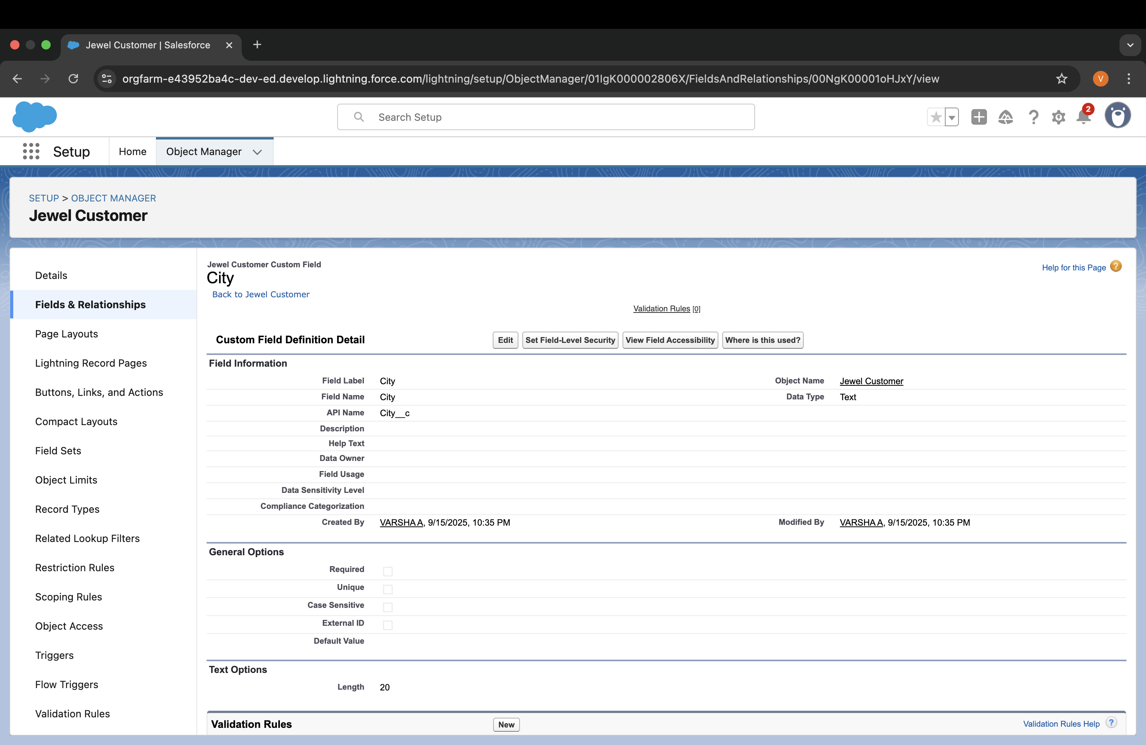

# Creating the Phone field in object Jewel Customer

To create fields in an object:

1. Go to setup >> click on Object Manager >> type object name(Jewel Customer ) in quick find bar >> click on the object.
2. Now click on “Fields & Relationships” >> New
3. Select Data type as “Phone” and click Next.
4. Given the Field Label as “ Phone”.
5. Field Name will be auto populated, and click on Next >> Next >> Save & new.

**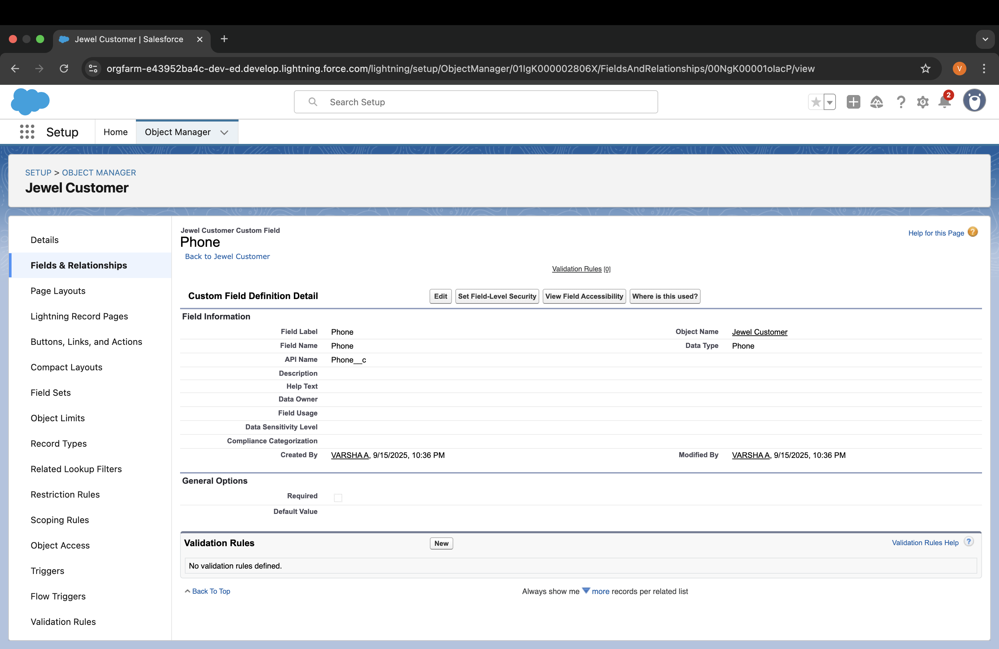****Creating the Email field in object Jewel Customer**

To create fields in an object:

* 1. Go to setup >> click on Object Manager >> type object name(Jewel Customer ) in quick find bar >> click on the object.
  2. Now click on “Fields & Relationships” >> New
  3. Select Data type as “Email” and click Next.
  4. Given the Field Label as “ Email”.
  5. Field Name will be auto populated, and click on Next >> Next >> Save.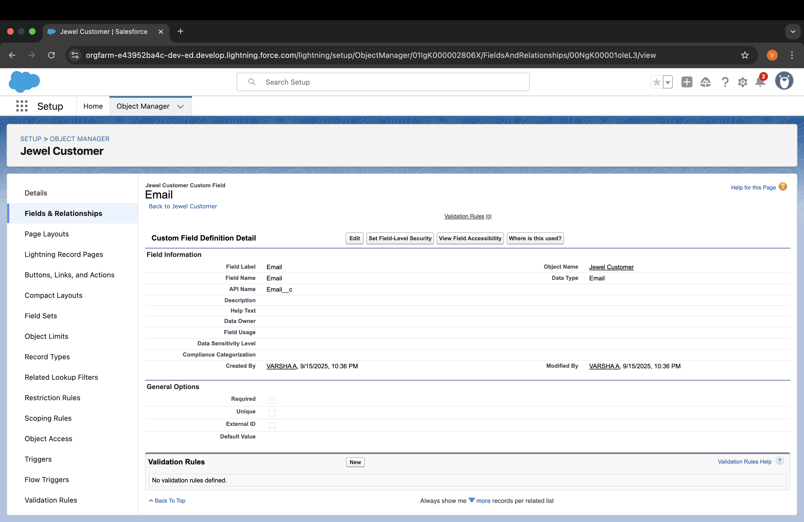

# Creating the number field in Item object

To create fields in an object:

1. Go to setup >> click on Object Manager >> type object name(Item) in quick find bar? click on the object.
2. Now click on “Fields & Relationships” >> New
3. Select Data type as “Number” and click Next.
4. Given the Field Label as “ Purity” and length as “ 2 ”.
5. Field Name will be auto populated, and click on Next >> Next >> Save.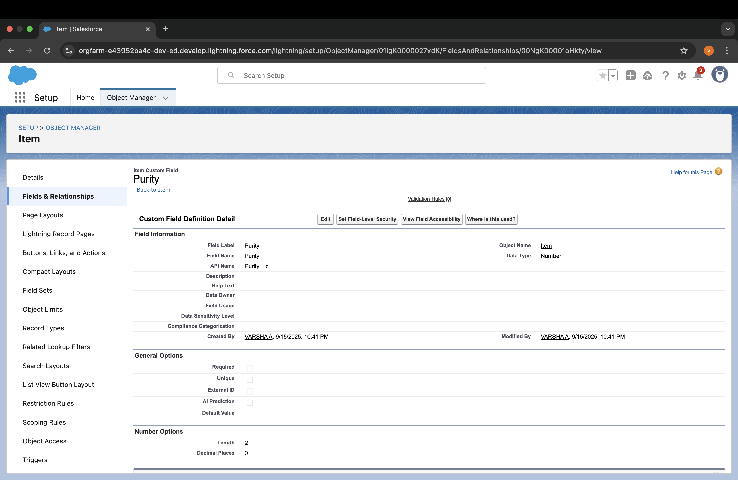Creating **Picklist Field in Item Object To create fields in an object:**
6. Go to setup >> click on Object Manager >> type object name(Item) in quick find bar>> click on the object.
7. Now click on “Fields & Relationships” >> New.
8. Select Data type as “Picklist” and click Next.
9. Enter Field Label as “Item Type”.
10. In values select “Enter values(Gold,Silver), with each value separated by a new line" and enter values as shown below.
11. Click Next? Next ? Next ? Save .

# Creating Currency Field in Price Object

To create fields in an object:

1. Go to setup >> click on Object Manager >> type object name(Price) in quick find bar >> click on the object.
2. Now click on “Fields & Relationships” >> New.
3. Select Data type as “Currency” and click Next.
4. Enter Field Label as “Gold Price” and length as “ 8”and decimal 0.Field name will be auto generated.
5. Click Next >> Next >> Next >> Save .

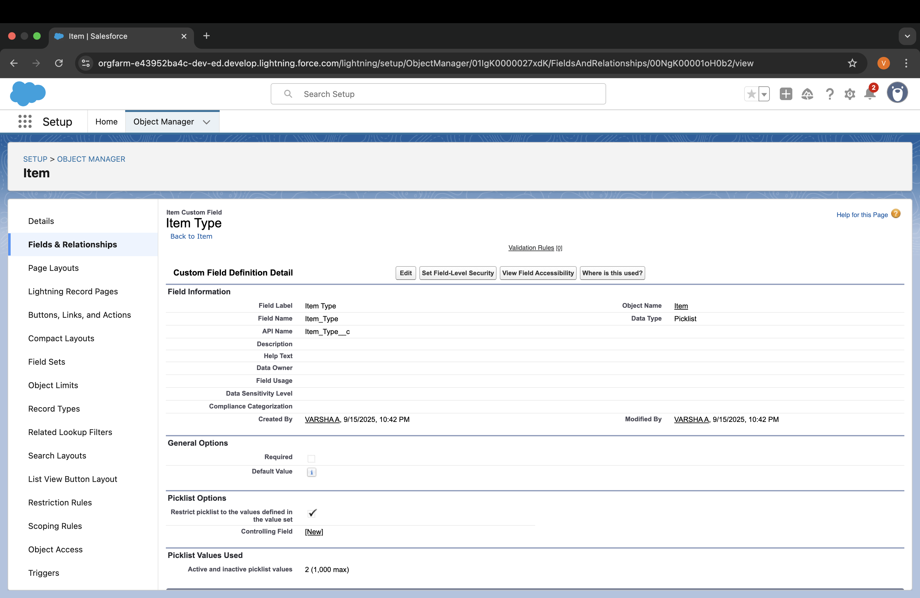

**Creating Formula Field(Cross Object) in Item Object To create fields in an object:**

(Note:Create a Lookup Relationship in Item Object to Price Object with Field

Name:Prices)

1. Go to setup >> click on Object Manager >> type object name(Item) in quick find bar? click on the object.
2. Now click on “Fields & Relationships” >> New.
3. Select Data type as “Formula” and click Next.
4. Give Field Label and Field Name as “Gold Price” and select formula return type as “Currency” and click next.
5. Under Advanced Formula write down the formula

:Prices r.Gold_price c / 10.

1. click “Check Syntax” and Next >> Next >> Save & New.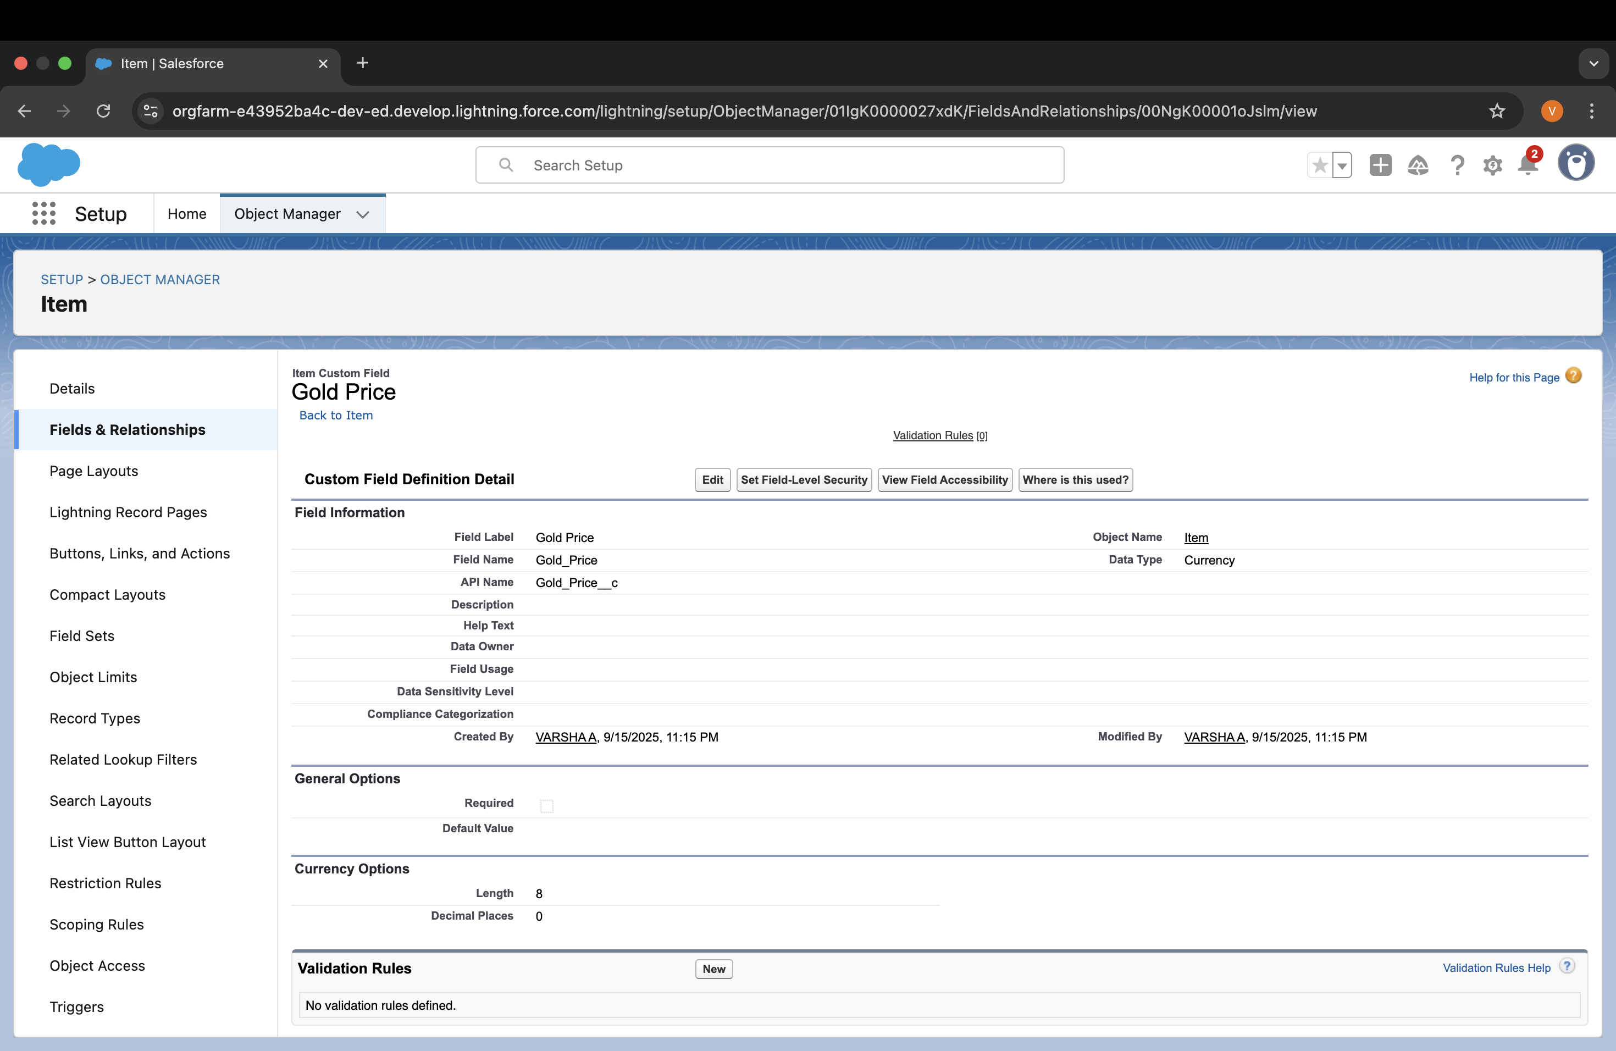

## Creating Remaining Fields in Objects

Now create the remaining fields using the data types mentioned.

|  |  |  |
| --- | --- | --- |
| s.no | Object name | Fields |
| 1 | Jewel Customer | Field Name Data type State Text(20)  Street Text(20)  Country Text(18)  Zip/Postal code Text(6) |

|  |  |  |
| --- | --- | --- |
| 2 | Price | Silver Price Currency (Length=8,Decimal=5) |

|  |  |  |  |  |
| --- | --- | --- | --- | --- |
| 3 | Ite m |  | | |
|  | Field Label:Customer Name | Lookup Relationship with Jewel Customer Object |
| Ornament | Text(20) |
| Weight | Number (Length=8,Decimal=5) |
|  |  |

Stone Weight Percentage Stone/Other Price

Expected Days Of Return

Number (Length=5,Decimal=5)

Number (Length=2,Decimal=0)

Currency (Length=8,Decimal=2)

Picklist

1-3 Days

4-5 Days

6-7 Days

8-10 Days

Priority Picklist

Low Medium High Critical

Silver Price

Formula

(Return Type:Number) (Decimal=3)

(Prices r.Silver_price c

/ 1000)

|  |  |  |  |  |  |
| --- | --- | --- | --- | --- | --- |
|  |  |  |  |  |  |
| Purity Gold Price | Formula  (Return Type:Currency) (Decimal=2) |  |
|  | ((Prices r.Gold_price_  _c * Purity c ) / 24) / 10 |
| Total Weight | Formula  (Return Type:Number) (Decimal=3) |  |
|  | (Weight c - Stone_weight c) |
| Amount | Formula  (Return Type:Currency) (Decimal=3) |  |
|  | IF(ISPICKVAL( Item_Type c ,"G Total_weight c * Purity_Gold_p c , Total_weight c * Silver_price | ol ric  _ |
|  |  |
| KDM | Formula  (Return Type:Currency) (Decimal=0) |  |
|  | (Amount c * Perc entage c ) / 100 |
| Making Charges | Formula |  |
|  |  |  |

|  |  |  |  |
| --- | --- | --- | --- |
| 4 | Customer Order |  |  |
|  |  | Order Status | Picklist |
|  |  |  | Started  Not Started On Hold Completed  Not Completed |

(Return Type:Currency) (Decimal=0)

IF(ISPICKVAL(

Item_Type c

,"Gold"), Weight c

* 300

, Weight c * 10 )

|  |  |  |  |  |  |
| --- | --- | --- | --- | --- | --- |
|  | 5 | Billing |  | | |
|  | Field Label:Item | Lookup Relationship with Item Object |
| Ornament | Formula  (Return Type:Text)  Item r.Ornament c |
|  |  |

KDM Charge

Formula

(Return Type:Currency)

Formula

(Return Type:Number) (Decimal=2)

Item r.Stone_weight_

_c

Weight

Formula

Return Type:Number (Decimal=2)

Item r.Total_weight_

_c

Amount

Formula

(Return Type:Currency) (Decimal=2)

Item r.Amount_

_c

Gold/Silver Price

Formula

(Return Type:Currency) (Decimal=2)

IF(ISPICKVAL( Item r.Item_Type_

_c ,"Gold"), Item r.Gold_price c , Item r.Silver_price c )

|  |  |  |  |  |  |  |  |
| --- | --- | --- | --- | --- | --- | --- | --- |
|  |  |  |  |  |  | |  |
|  | (Decimal=0)  Item r.KDM_  _c | |  |
| Making Charges | Formula  (Return Type:Currency) (Decimal=2)  Item r.Making_Charges c | |  |
| Stones/other price | Formula  (Return Type:Currency) (Decimal=2)  Item r.Stone_other_price c | |  |
| Total Amount | Formula  (Return Type:Currency) (Decimal=0) | |  |
|  | Amount c +  KDM_Charge c + Stones_other_price c + Making_Charges c |
|  | |
|  |  | |  |

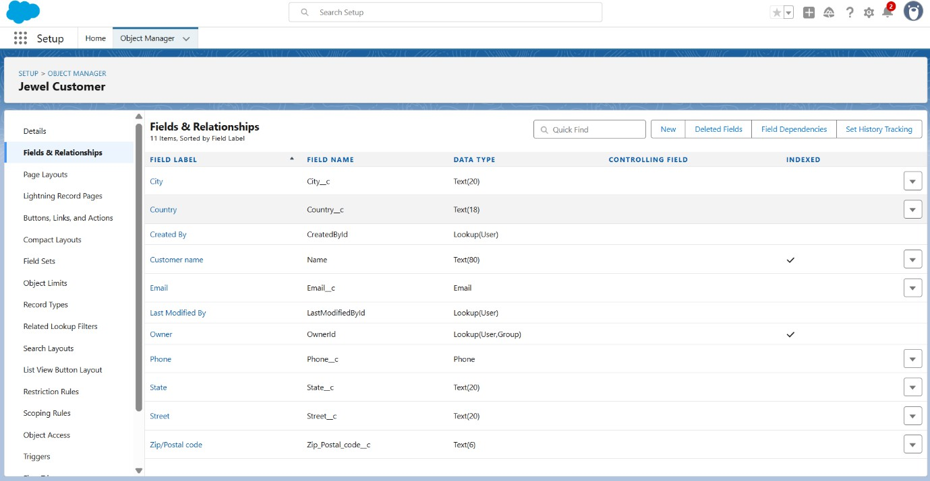

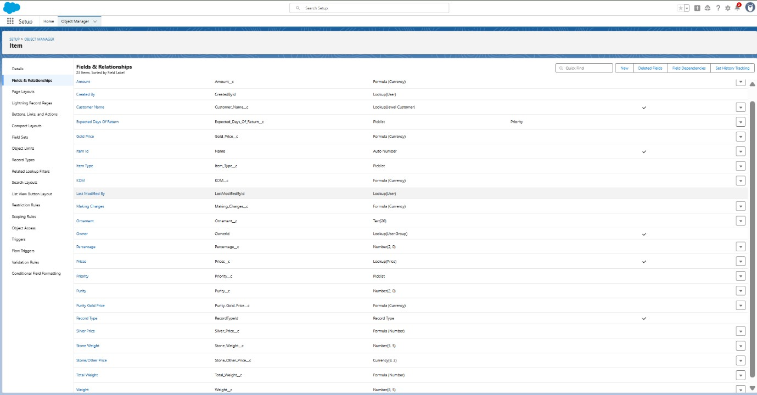

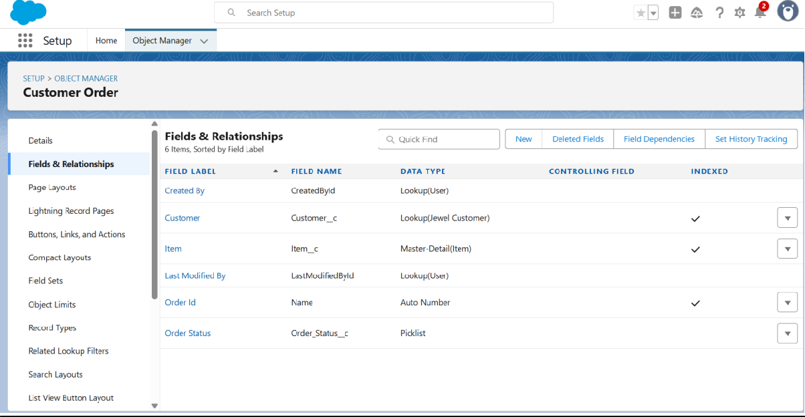

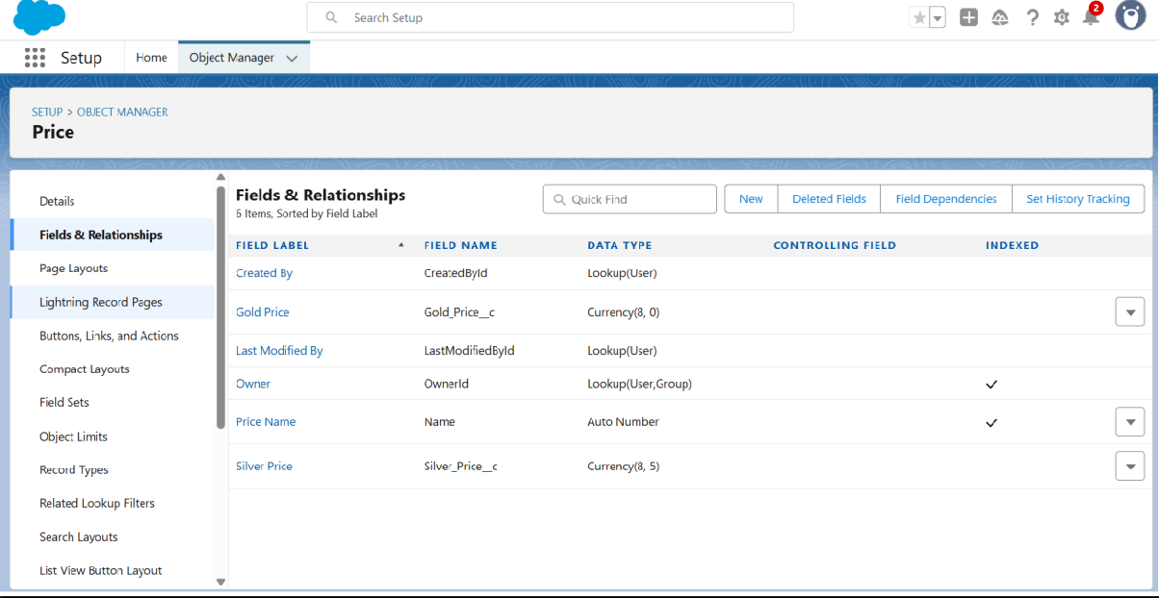

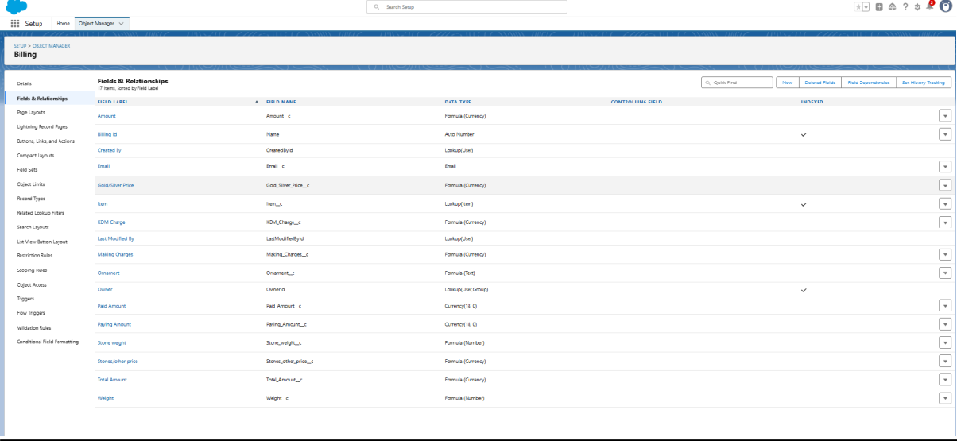

# Gold Smith Profile

To create a new profile:

1. Go to setup >> type profiles in quick find box >>click on profiles ? clone the desired profile (System Administrator) >> enter profile name (Gold Smith) >> Save.
2. While still on the profile page, then click Edit.
3. Scroll down to Custom Object Permissions and Give access permissions for Jewel Customer,Item,Customer Order,Prices,Billings .
4. Scroll down and Click on Save.

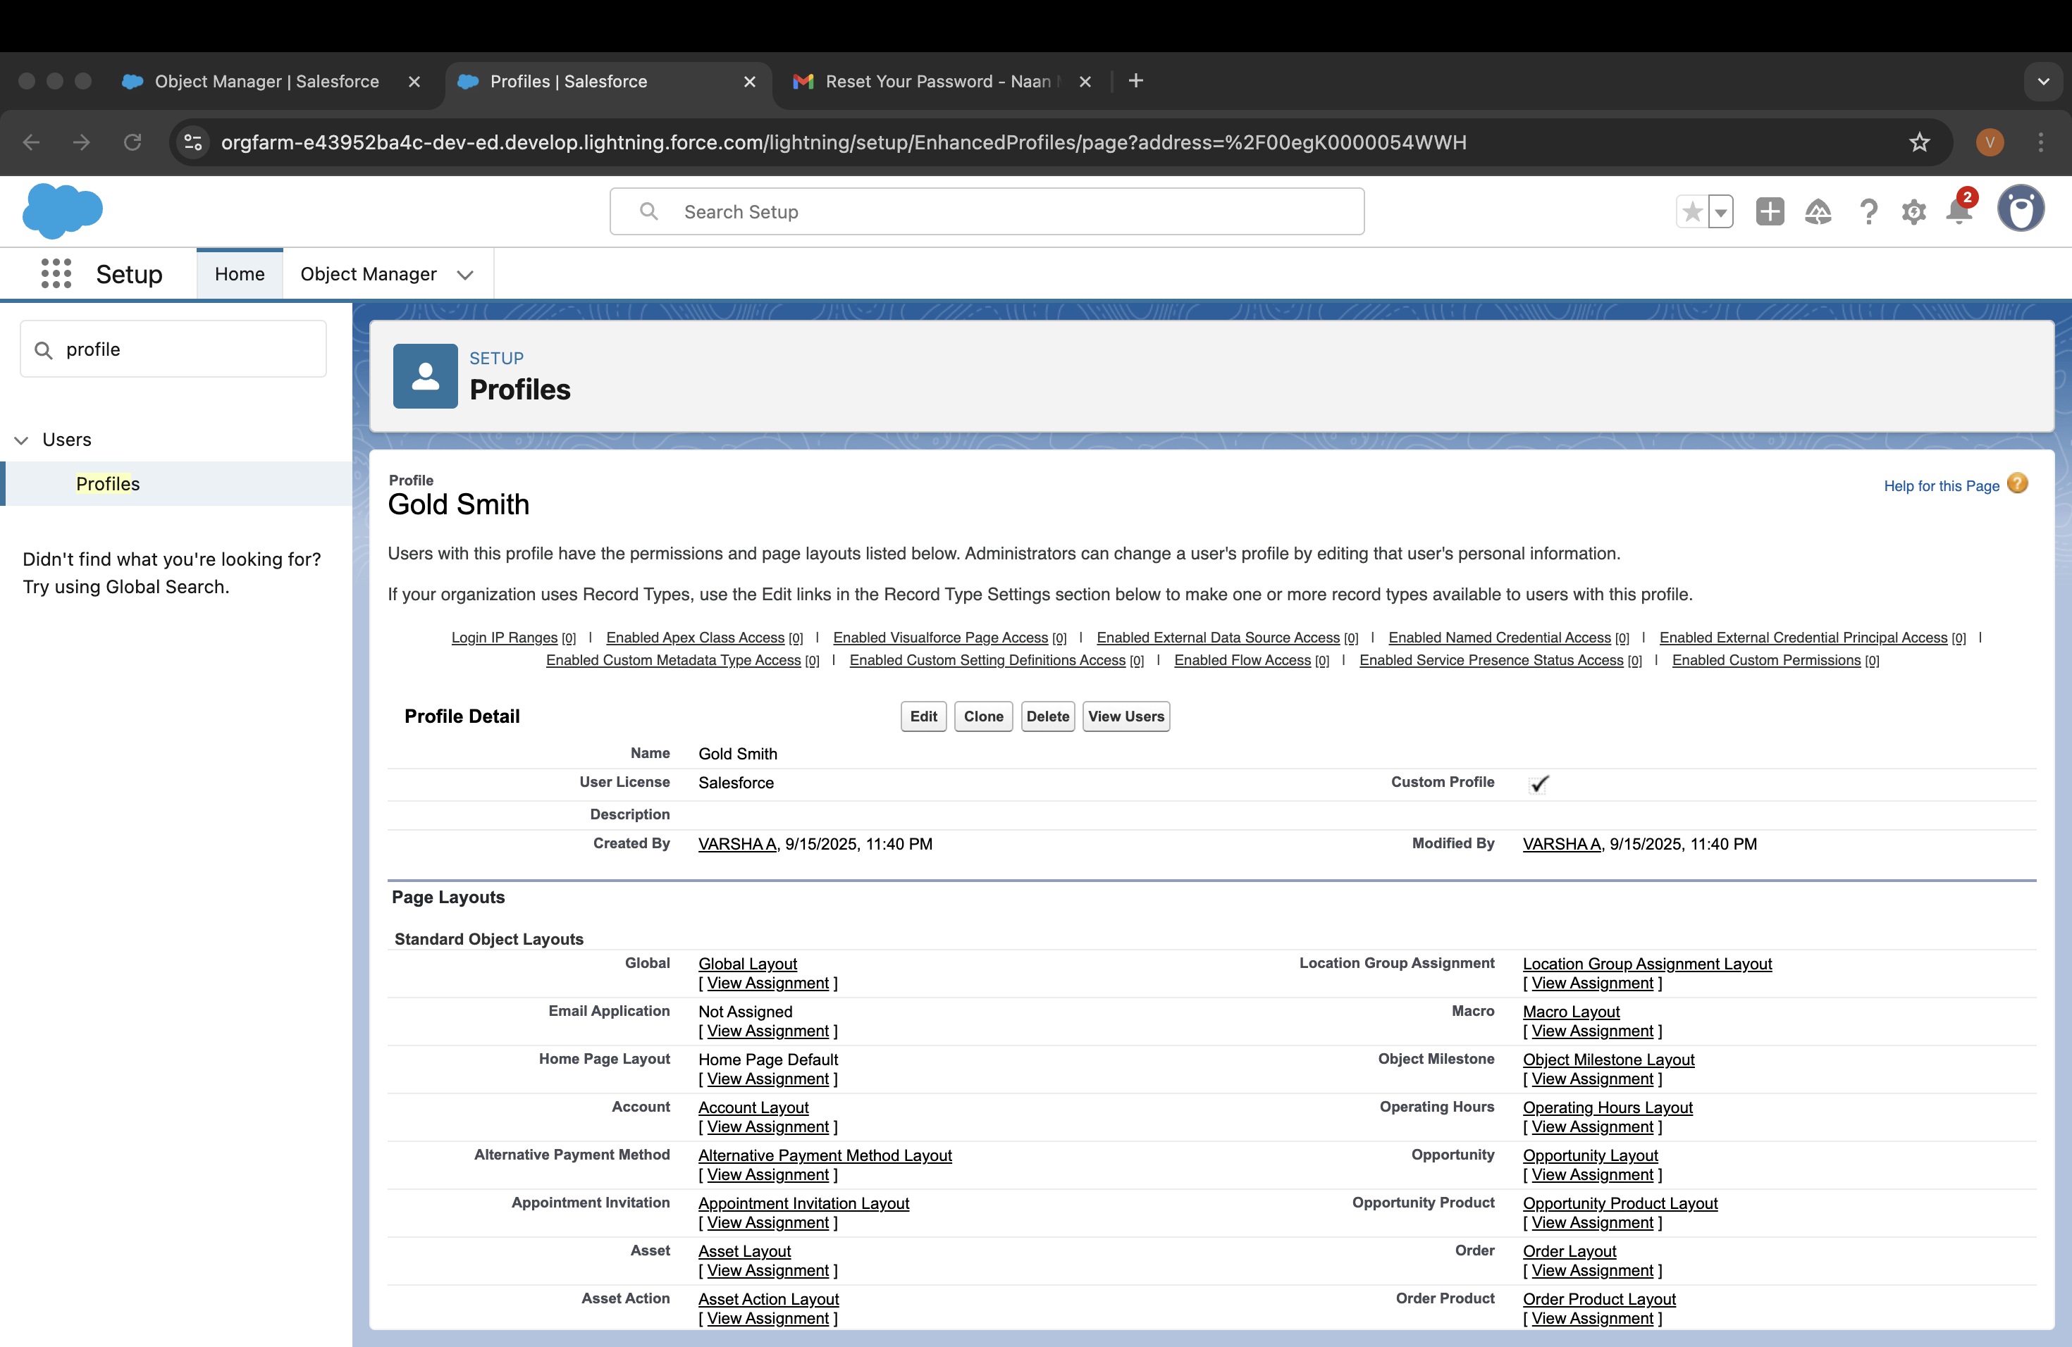

# Worker Profile

1. Go to setup >> type profiles in quick find box >> click on profiles >> clone the desired profile (Salesforce Platform User) >> enter profile name (Worker) >> Save.
2. While still on the profile page, then click Edit.
3. Scroll down to Custom Object Permissions and Give access permissions for Items,Price and Customer Order objects.
4. Scroll down and Click on Save.

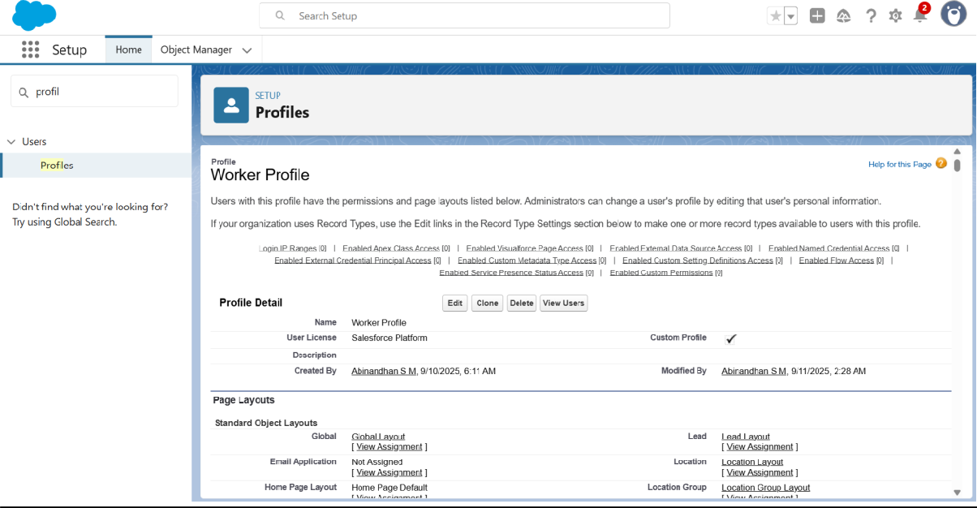

# Creating Gold Smith Role

1. From setup ,Go to quick find >> Search for Roles >> click on set up roles.
2. Click on Expand All and click on add role under whom this role works.
3. Give Label as “Gold Smith” and Role name gets auto populated. Check to whom this role (Gold Smith) reports. Then click on Save.

# Creating Worker Role

1. From setup ,Go to quick find >> Search for Roles >> click on set up roles.
2. Click on Expand All and click on add role under whom this role works.
3. Give Label as “Worker” and Role name gets auto populated. Check to whom this role (Gold Smith) reports. Then click on Save.

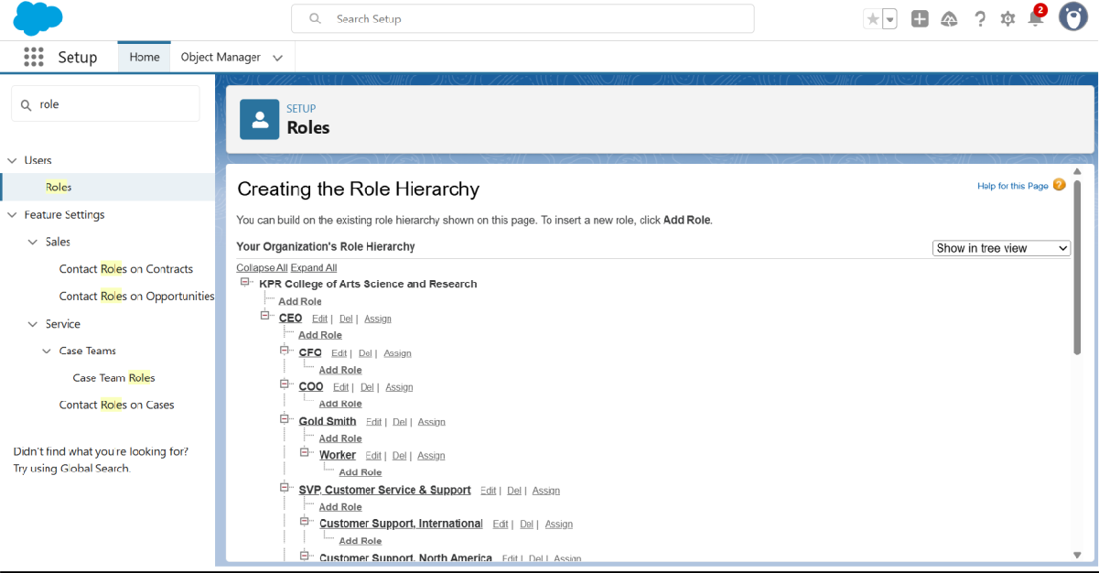

# Create User

1. Go to setup >> type users in quick find box >> select users >> click New user.
2. Fill in the fields
   1. First Name : Niklaus
   2. Last Name : Mikaelson
   3. Alias : Give a Alias Name
   4. Email id : Give your Personal Email id
   5. Username : Username should be in this form: [text@text.text](mailto:text@text.text)
   6. Nick Name : Give a Nickname
   7. Role : Gold Smith
   8. User licence : Salesforce
   9. Profiles : Gold Smith

# Create User

1. Go to setup >> type users in quick find box >> select users >> click New user.
2. Fill in the fields
   * First Name : Kol
   * Last Name : Mikaelson
   * Alias : Give a Alias Name
   * Email id : Give your Personal Email id
   * Username : Username should be in this form: [text@text.text](mailto:text@text.text)
   * Nick Name : Give a Nickname
   * Role : Worker
   * User licence : Salesforce Platform
   * Profiles : Worker
3. Save.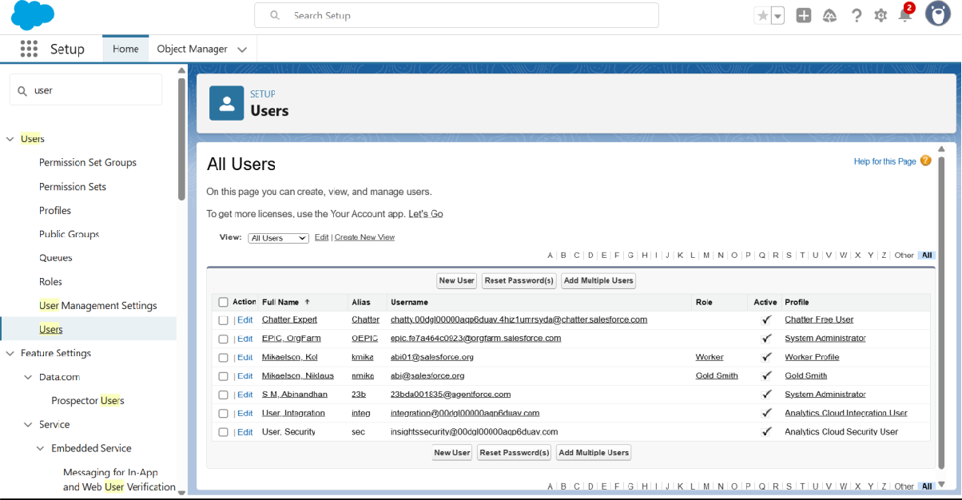

# To Create a Gold Page layout

1. Go to Setup >> Click on Object Manager >> Search for the object (Item) >> From drop down click on Edit.
2. Click on Page layout >> Click on New.
3. Give Page layout Name as “Page Layout for Gold” and click on Save and New.
4. Arrange the field as shown in the Information Section ,remove fields which are related to Silver and click Ok.
5. Click Save.
6. Make sure your page layout looks like the picture above.

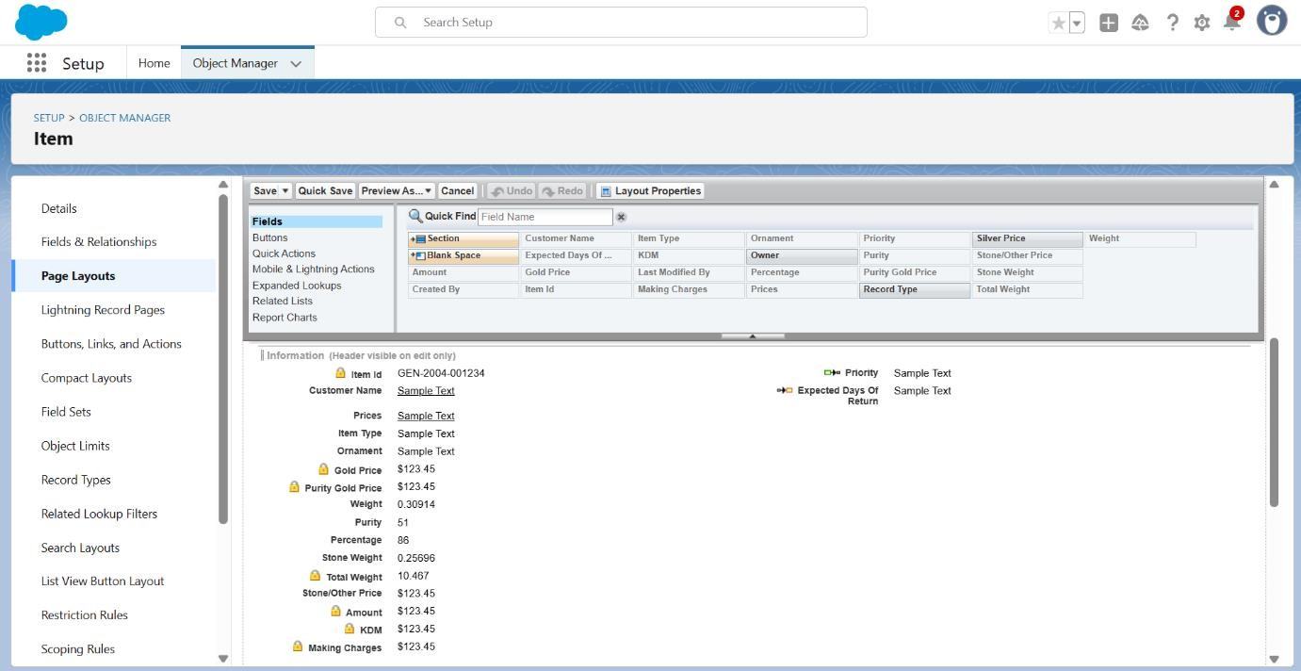

# To Create a Silver Page layout

1. Go to Setup >> Click on Object Manager >> Search for the object (Item) >> From drop down click on Edit.
2. Click on Page layout >> Click on New.
3. Give Page layout Name as “Page Layout for Silver” and click on Save.
4. Arrange the field as shown in the Information Section ,remove fields which are related to Gold and click Ok.

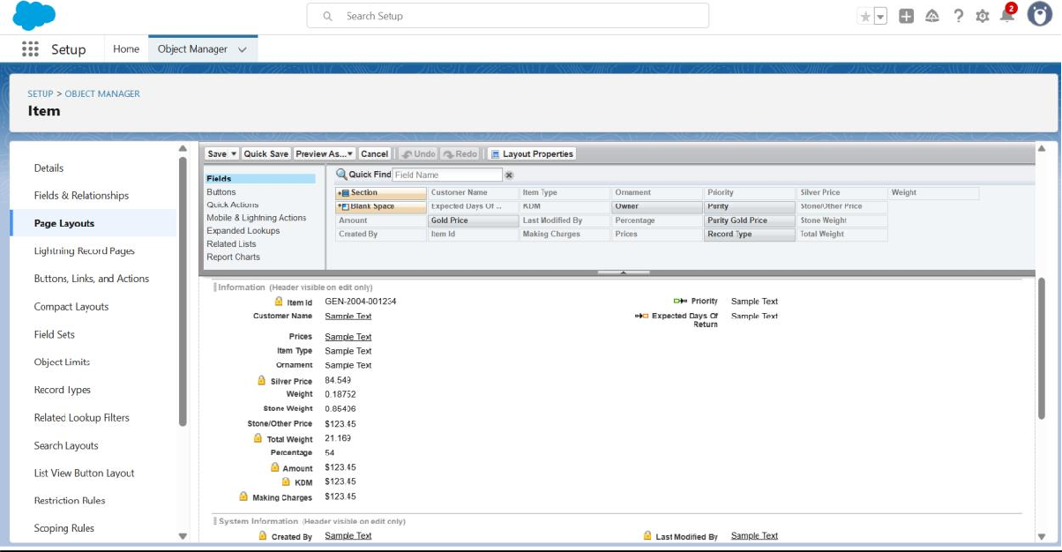

# To create a Record Type

1. Go to setup >> click on Object Manager >> type object name(Item) in quick find bar? click on the object.
2. Click on the Record Types >> click New.
3. Select Existing Record as “Master”,Record type Label as “Gold”,Description as “Gold items information”.
4. Uncheck for “Make Available”.
5. Scroll down and check for the Gold Smith,Worker JW & System Administrator profile and click on Next.
6. Select “Apply a different layout for each profile”, and change page layout to “Page Layout for Gold“for Gold Smith,Worker and System Administrator ? save & new.

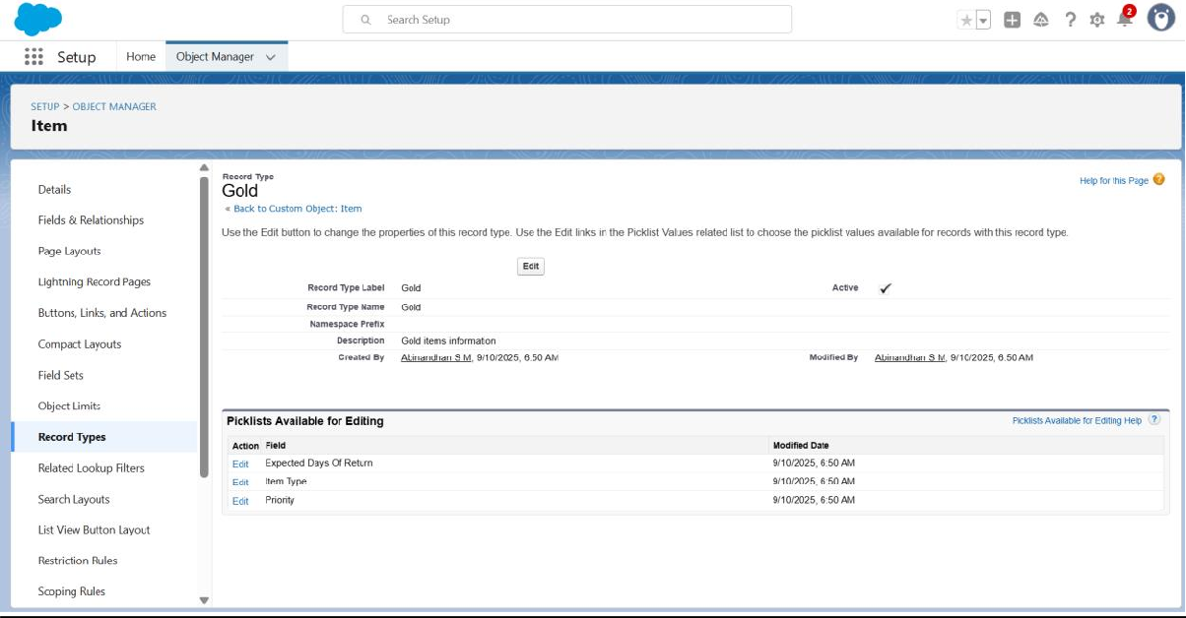

# To create a Record Type

1. Go to setup >> click on Object Manager >> type object name(Item) in quick find bar? click on the object.
2. Click on the Record Types >> click New.
3. Select Existing Record as “Master”,Record type Label as “Silver”,Description as “Silver items information”.
4. Uncheck for “Make Available”.
5. Scroll down and check for the Gold Smith,Worker JW & System Administrator profile and click on Next.
6. Select “Apply a different layout for each profile”, and change page layout to “Page Layout for Silver“for Gold Smith,Worker and System Administrator ? save & new.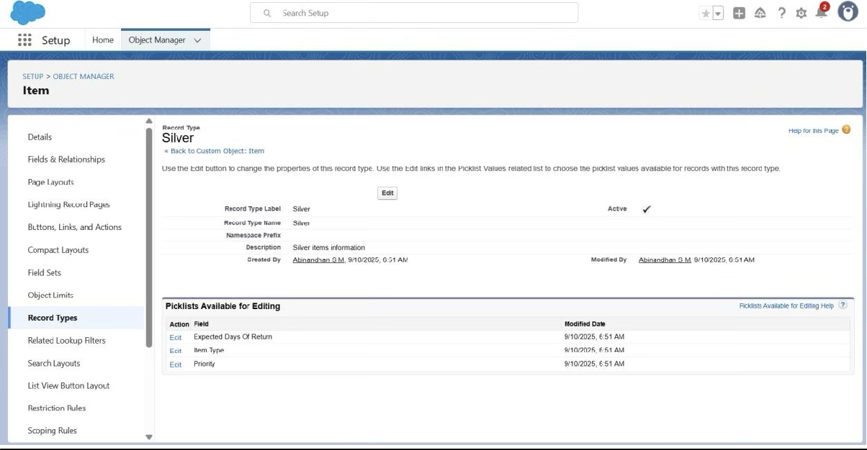

# Creating permission set

1. Go to setup >> type “permission sets” in quick search >> select permission sets >> New.
2. Enter the label name as “Per to Worker”, API will be auto populated ? save.
3. Under Apps Select object settings.
4. Click on Items object ? click on Edit ? under Item:Record Type Assignments,enable Gold,Silver ? Object permission check for read ,edit and create.
5. Click on Save.
6. After saving the permission click on the Manage assignment
7. Now click on the Add Assignment.
8. Now select the users which you have created in user milestone, using Worker profile and click on Next ? Assign? Done.

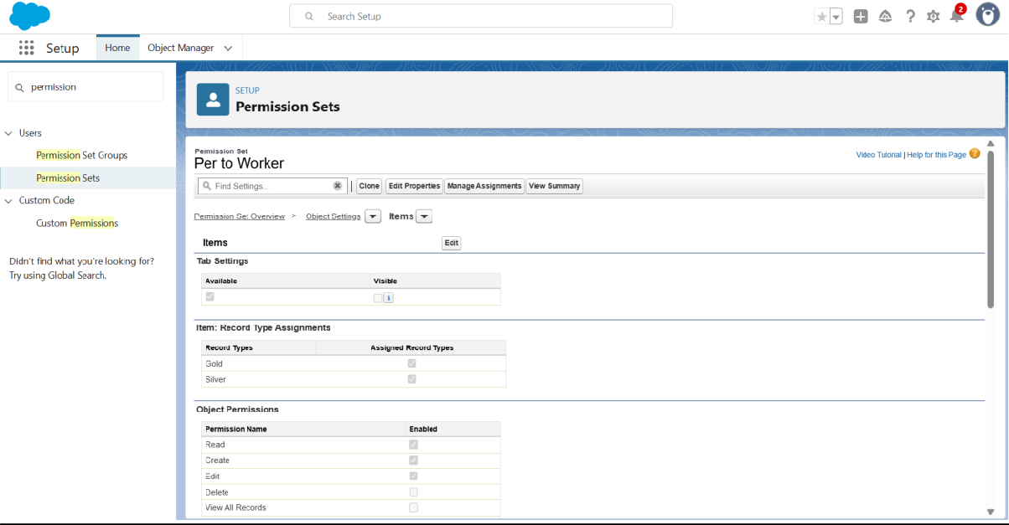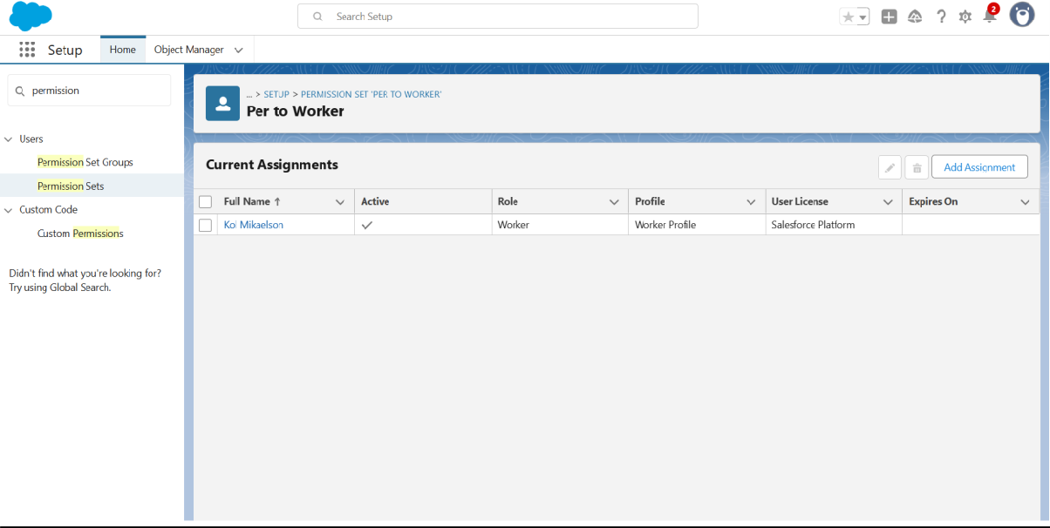

# Create a Trigger Handler class

## CODE:

public class UpdatePaidAmountTriggerHandler {

public static void handleBeforeInsert(List<Billing c> newBillings) { for (Billing c billing : newBillings) {

billing.Paid_Amount c = billing.Paying_Amount c;

}

}

public static void handleBeforeUpdate(Map<Id, Billing c> oldBillingsMap, List<Billing c> updatedBillings) {

for (Billing c billing : updatedBillings) {

Billing c oldBilling = oldBillingsMap.get(billing.Id); Decimal oldPaidAmount = oldBilling.Paid_Amount c;

billing.Paid_Amount c = oldPaidAmount + billing.Paying_Amount c;

}

}

}

# Create the trigger

## CODE:

trigger UpdatePaidAmountTrigger on Billing c (before insert, before update) { if (Trigger.isInsert) {

UpdatePaidAmountTriggerHandler.handleBeforeInsert(Trigger.new);

} else if (Trigger.isUpdate) { UpdatePaidAmountTriggerHandler.handleBeforeUpdate(Trigger.oldMap,

Trigger.new);

}

}

# Create a Record (Jewel Customer)

1. Click on App Launcher on the left side of the screen.
2. Search Jewelry Inventory System & click on it.
3. Click on Drop Down and Click on the Jewel Customer tab.
4. Click New.
5. Fill the Details and click on Save.

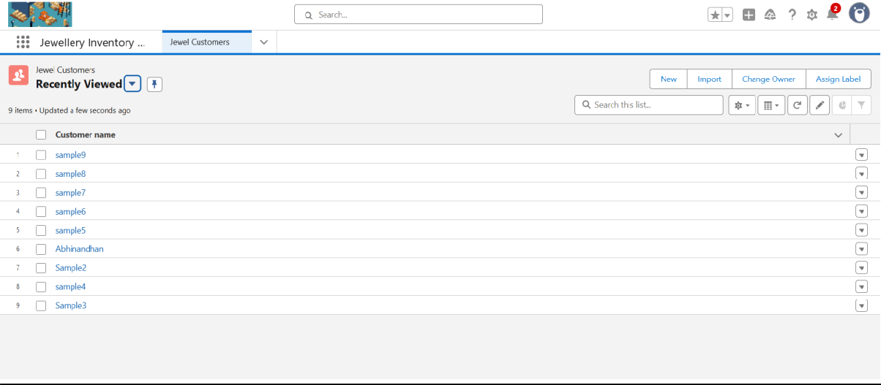

# View a Record(Jewel Customer)

1. Click on App Launcher on the left side of the screen.
2. Search Jewelry Inventory System & click on it.
3. Click on the Jewel Customer Tab.
4. Click on any record name. you can see the details of the Jewel Customer.

# Delete a Record(Jewel Customer)

1. Click on App Launcher on the left side of the screen.
2. Search Jewelry Inventory System & click on it.
3. Click on the Jewel Customer Tab.
4. Click on Arrow at right hand side on that Particular record.
5. Click delete.

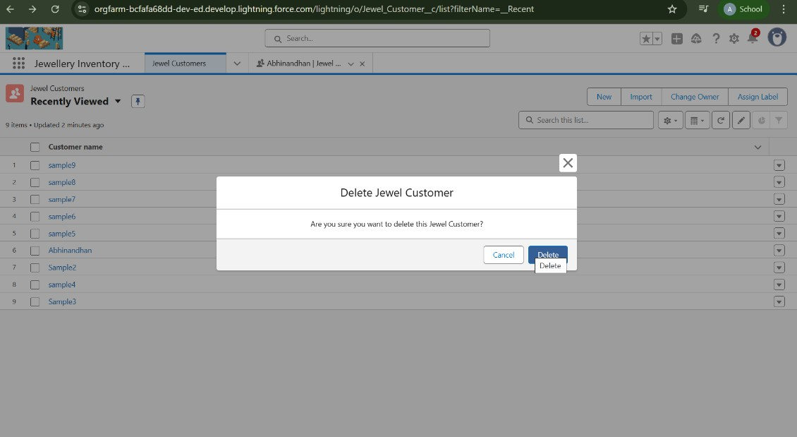

# Create Report

1. Go to the app >> click on the reports tab
2. Click New Report.
3. Select report type from category or from report type panel or from search panel ? click on start report.
4. Customise your report
5. Add fields from the left pane as shown.
6. Save or run it.
7. Create a report with report type: “Item with Billings”.
8. Create a report with report type: “Billings with item and Customer order”.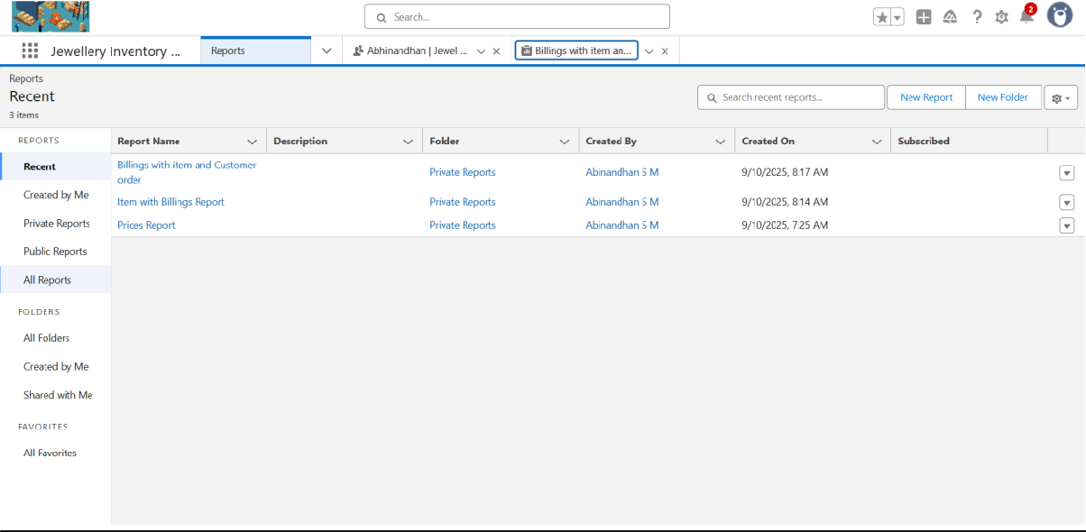

# Create Dashboard

1. Go to the app >> click on the Dashboards tabs.
2. Give a Name and click on Create.
3. Select add component.
4. Select a Report and click on select.
5. Click Add then click on Save and then click on Done.

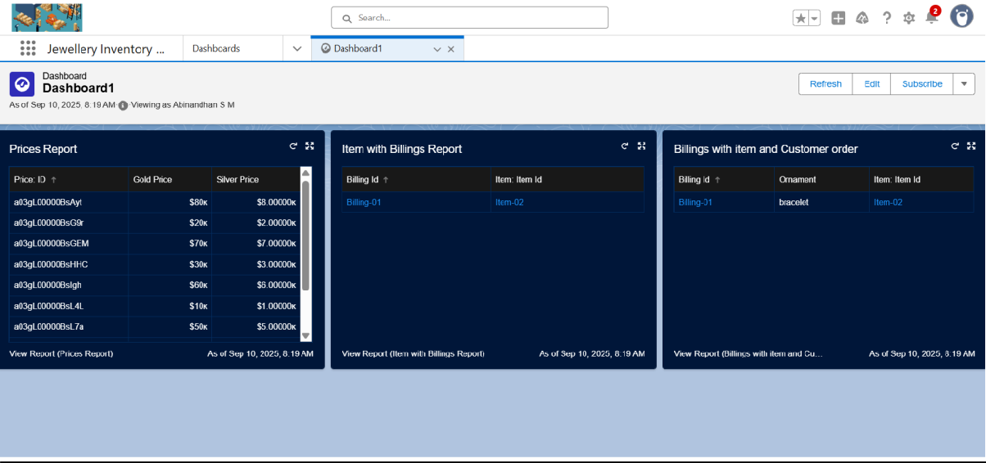

# Create a Flow

* 1. Go to setup >> type Flow in quick find box >> Click on the Flow and Select the New Flow.
  2. Select the Record-triggered flow and Click on Create.
  3. Select the Object as a “Billing” in the Drop down list.
  4. Select the Trigger Flow when: “A record is Created or Updated”.
  5. Select the Optimise the flow for: “Actions and Related Records” and Click on Done.
  6. Now change the mode form Auto-layout to free-form.
  7. Now select the manger option in the toolbox, click New resource.
  8. Select the resource type as text template.
  9. Change the view as Rich Text ? View to Plain Text.
  10. In the body field paste the syntax that is given below. Hello

Customer Name: {!$Record.Item r.Customer_Name r.Name}

Here are the details for the item you purchased with Jewellery Inventory System

Item Type: {!$Record.Item r.Item_Type c} Ornament: {!$Record.Ornament c}

Weight: {!$Record.Weight c}grams Amount: {!$Record.Amount c}

* 1. Click done.
  2. Now click on elements, and drag the action element into the preview pane.
  3. Their action bar will be opened in that search for “ send email ” and click on it.
  4. Give the label name as “ notice”
  5. API name will be auto populated.
  6. 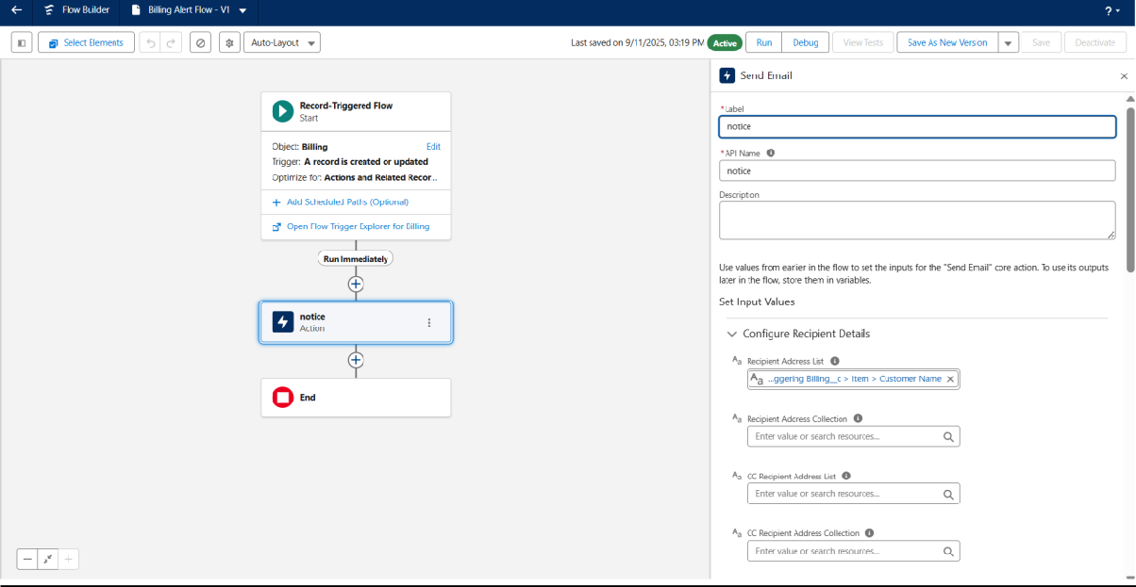Enable the body in set input values for the selected action.
  7. Select the text template that was created.
  8. Include Recipient Address list, select the email form the record. ({!$Record.Item_r.Customer_Namer.Email_c})
  9. Include the subject as “Welcome to Jewelry Inventory System ”.
  10. Click done.
  11. Now drag the path from the start to the action element.
  12. Click on save. Given the Flow label , Flow Api name will be auto populated.
  13. 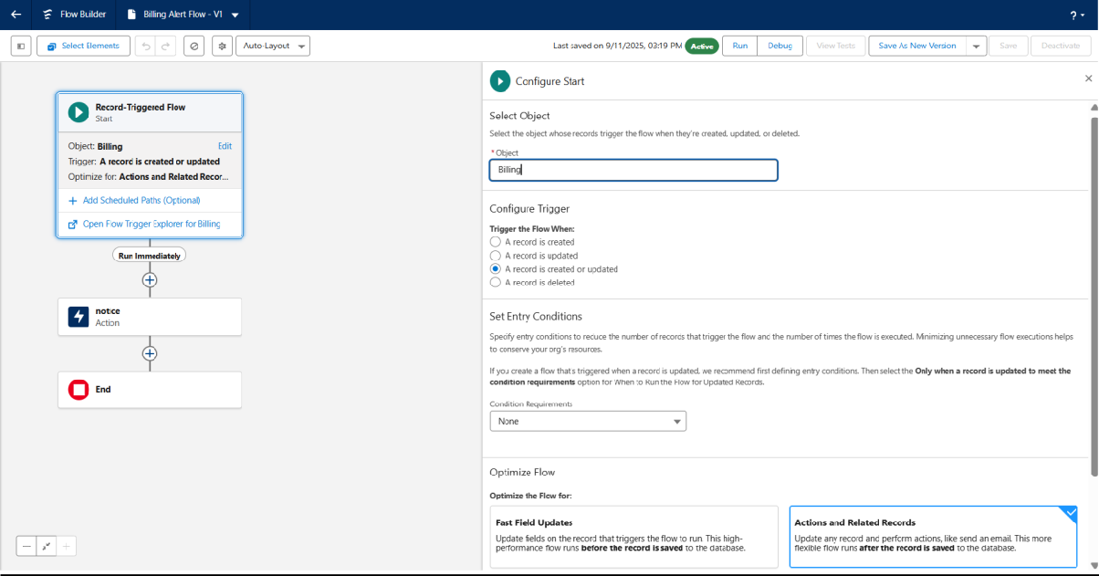And click save, and click on activate.

